**Parameter Tuning**

# Scenario 1

| **params** | **rank_test_score** | **mean_test_score** | **std_test_score** |
| --- | --- | --- | --- |
| **kernel** |  |  |  |  |
| 3_0.24574 | {'C': 3, 'gamma': 0.24574} | 1 | 0.893145 | 0.017379 |
| 3_0.25086 | {'C': 3, 'gamma': 0.25086} | 2 | 0.892345 | 0.016273 |
| 3_0.26622 | {'C': 3, 'gamma': 0.26622} | 3 | 0.891544 | 0.016953 |
| 3_0.25598 | {'C': 3, 'gamma': 0.25598} | 4 | 0.891145 | 0.015627 |
| 6_0.24574 | {'C': 6, 'gamma': 0.24574} | 5 | 0.890745 | 0.015871 |
| 6_0.26622 | {'C': 6, 'gamma': 0.26622} | 6 | 0.890745 | 0.016666 |
| 3_0.2611 | {'C': 3, 'gamma': 0.2611} | 6 | 0.890745 | 0.015523 |
| 15_0.26622 | {'C': 15, 'gamma': 0.26622} | 8 | 0.890345 | 0.016364 |
| 10_0.26622 | {'C': 10, 'gamma': 0.26622} | 8 | 0.890345 | 0.016364 |
| 15_0.24574 | {'C': 15, 'gamma': 0.24574} | 10 | 0.889945 | 0.015114 |
| 6_0.25086 | {'C': 6, 'gamma': 0.25086} | 10 | 0.889945 | 0.015635 |
| 10_0.24574 | {'C': 10, 'gamma': 0.24574} | 10 | 0.889945 | 0.015114 |
| 15_0.25086 | {'C': 15, 'gamma': 0.25086} | 13 | 0.889145 | 0.014877 |
| 15_0.2611 | {'C': 15, 'gamma': 0.2611} | 13 | 0.889145 | 0.014385 |
| 6_0.2611 | {'C': 6, 'gamma': 0.2611} | 13 | 0.889145 | 0.015196 |
| 10_0.25086 | {'C': 10, 'gamma': 0.25086} | 13 | 0.889145 | 0.014877 |
| 10_0.2611 | {'C': 10, 'gamma': 0.2611} | 13 | 0.889145 | 0.014385 |
| 10_0.25598 | {'C': 10, 'gamma': 0.25598} | 18 | 0.888745 | 0.014549 |
| 15_0.25598 | {'C': 15, 'gamma': 0.25598} | 18 | 0.888745 | 0.014549 |
| 6_0.25598 | {'C': 6, 'gamma': 0.25598} | 20 | 0.888345 | 0.014371 |
| 1_0.25598 | {'C': 1, 'gamma': 0.25598} | 21 | 0.883945 | 0.010908 |
| 1_0.25086 | {'C': 1, 'gamma': 0.25086} | 22 | 0.883545 | 0.010334 |
| 1_0.2611 | {'C': 1, 'gamma': 0.2611} | 23 | 0.883545 | 0.011655 |
| 1_0.26622 | {'C': 1, 'gamma': 0.26622} | 23 | 0.883545 | 0.011655 |
| 1_0.24574 | {'C': 1, 'gamma': 0.24574} | 25 | 0.882745 | 0.010110 |

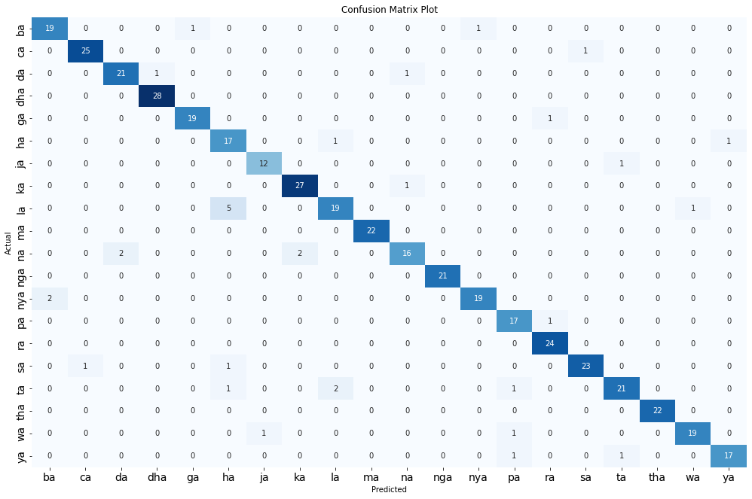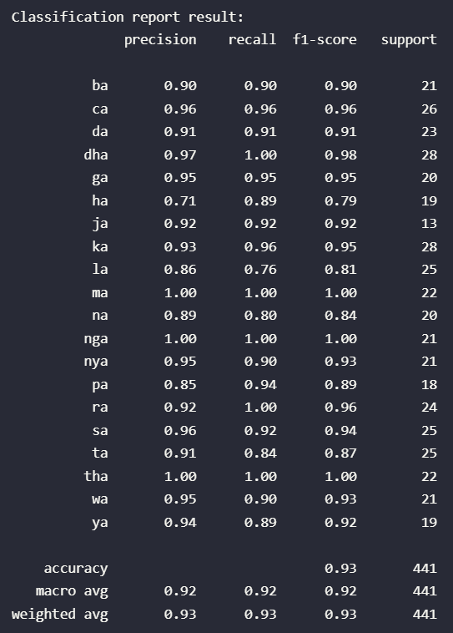

# Scenario 2

| **params** | **rank_test_score** | **mean_test_score** | **std_test_score** |
| --- | --- | --- | --- |
| **kernel** |  |  |  |  |
| 6_0.20504 | {'C': 6, 'gamma': 0.20504} | 1 | 0.906361 | 0.004494 |
| 15_0.20504 | {'C': 15, 'gamma': 0.20504} | 2 | 0.905961 | 0.004932 |
| 10_0.20504 | {'C': 10, 'gamma': 0.20504} | 2 | 0.905961 | 0.004932 |
| 6_0.21358 | {'C': 6, 'gamma': 0.21358} | 4 | 0.905561 | 0.005738 |
| 6_0.20931 | {'C': 6, 'gamma': 0.20931} | 4 | 0.905561 | 0.004661 |
| 15_0.21358 | {'C': 15, 'gamma': 0.21358} | 6 | 0.905161 | 0.006294 |
| 15_0.20931 | {'C': 15, 'gamma': 0.20931} | 6 | 0.905161 | 0.005179 |
| 10_0.21358 | {'C': 10, 'gamma': 0.21358} | 6 | 0.905161 | 0.006294 |
| 10_0.20931 | {'C': 10, 'gamma': 0.20931} | 6 | 0.905161 | 0.005179 |
| 6_0.21785 | {'C': 6, 'gamma': 0.21785} | 6 | 0.905161 | 0.006294 |
| 3_0.20504 | {'C': 3, 'gamma': 0.20504} | 11 | 0.905158 | 0.006822 |
| 10_0.21785 | {'C': 10, 'gamma': 0.21785} | 12 | 0.904761 | 0.006898 |
| 15_0.21785 | {'C': 15, 'gamma': 0.21785} | 12 | 0.904761 | 0.006898 |
| 10_0.22212 | {'C': 10, 'gamma': 0.22212} | 14 | 0.904361 | 0.006390 |
| 15_0.22212 | {'C': 15, 'gamma': 0.22212} | 14 | 0.904361 | 0.006390 |
| 6_0.22212 | {'C': 6, 'gamma': 0.22212} | 16 | 0.903961 | 0.007054 |
| 3_0.21785 | {'C': 3, 'gamma': 0.21785} | 17 | 0.903959 | 0.006730 |
| 3_0.21358 | {'C': 3, 'gamma': 0.21358} | 18 | 0.903958 | 0.006977 |
| 3_0.20931 | {'C': 3, 'gamma': 0.20931} | 18 | 0.903958 | 0.006122 |
| 3_0.22212 | {'C': 3, 'gamma': 0.22212} | 20 | 0.902759 | 0.006794 |
| 1_0.21785 | {'C': 1, 'gamma': 0.21785} | 21 | 0.897551 | 0.011286 |
| 1_0.21358 | {'C': 1, 'gamma': 0.21358} | 21 | 0.897551 | 0.011907 |
| 1_0.20931 | {'C': 1, 'gamma': 0.20931} | 23 | 0.897549 | 0.013078 |
| 1_0.22212 | {'C': 1, 'gamma': 0.22212} | 24 | 0.897151 | 0.011011 |
| 1_0.20504 | {'C': 1, 'gamma': 0.20504} | 25 | 0.896349 | 0.012764 |

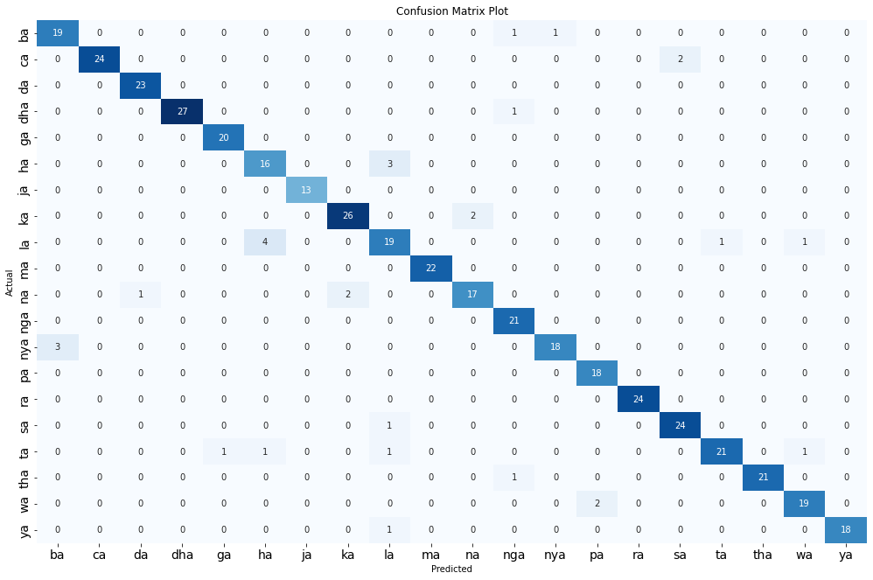

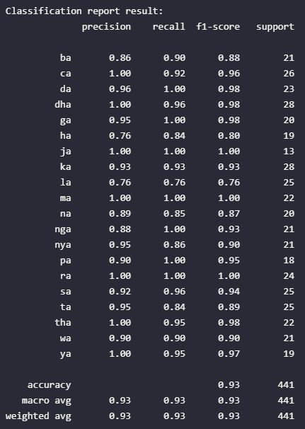

# Scenario 3

|  | **params** | **rank_test_score** | **mean_test_score** | **std_test_score** |
| --- | --- | --- | --- | --- |
| **kernel** |  |  |  |  |
| 15_0.13567 | {'C': 15, 'gamma': 0.13567} | 1 | 0.915566 | 0.010077 |
| 6_0.13567 | {'C': 6, 'gamma': 0.13567} | 1 | 0.915566 | 0.010077 |
| 10_0.13567 | {'C': 10, 'gamma': 0.13567} | 1 | 0.915566 | 0.010077 |
| 10_0.1385 | {'C': 10, 'gamma': 0.1385} | 4 | 0.915166 | 0.010327 |
| 15_0.1385 | {'C': 15, 'gamma': 0.1385} | 4 | 0.915166 | 0.010327 |
| 6_0.1385 | {'C': 6, 'gamma': 0.1385} | 4 | 0.915166 | 0.010327 |
| 10_0.14133 | {'C': 10, 'gamma': 0.14133} | 7 | 0.914765 | 0.010410 |
| 6_0.14133 | {'C': 6, 'gamma': 0.14133} | 7 | 0.914765 | 0.010410 |
| 15_0.14133 | {'C': 15, 'gamma': 0.14133} | 7 | 0.914765 | 0.010410 |
| 3_0.1385 | {'C': 3, 'gamma': 0.1385} | 10 | 0.914764 | 0.010868 |
| 3_0.13567 | {'C': 3, 'gamma': 0.13567} | 11 | 0.914364 | 0.010778 |
| 10_0.14416 | {'C': 10, 'gamma': 0.14416} | 12 | 0.913965 | 0.011668 |
| 15_0.14416 | {'C': 15, 'gamma': 0.14416} | 12 | 0.913965 | 0.011668 |
| 6_0.14416 | {'C': 6, 'gamma': 0.14416} | 12 | 0.913965 | 0.011668 |
| 3_0.14133 | {'C': 3, 'gamma': 0.14133} | 15 | 0.913963 | 0.011263 |
| 3_0.14416 | {'C': 3, 'gamma': 0.14416} | 15 | 0.913963 | 0.012217 |
| 10_0.14699 | {'C': 10, 'gamma': 0.14699} | 17 | 0.913164 | 0.011781 |
| 15_0.14699 | {'C': 15, 'gamma': 0.14699} | 17 | 0.913164 | 0.011781 |
| 6_0.14699 | {'C': 6, 'gamma': 0.14699} | 17 | 0.913164 | 0.011781 |
| 3_0.14699 | {'C': 3, 'gamma': 0.14699} | 20 | 0.912762 | 0.012324 |
| 1_0.14699 | {'C': 1, 'gamma': 0.14699} | 21 | 0.905960 | 0.007409 |
| 1_0.14416 | {'C': 1, 'gamma': 0.14416} | 22 | 0.905558 | 0.009458 |
| 1_0.14133 | {'C': 1, 'gamma': 0.14133} | 22 | 0.905558 | 0.009458 |
| 1_0.1385 | {'C': 1, 'gamma': 0.1385} | 24 | 0.904758 | 0.009301 |
| 1_0.13567 | {'C': 1, 'gamma': 0.13567} | 24 | 0.904758 | 0.010045 |

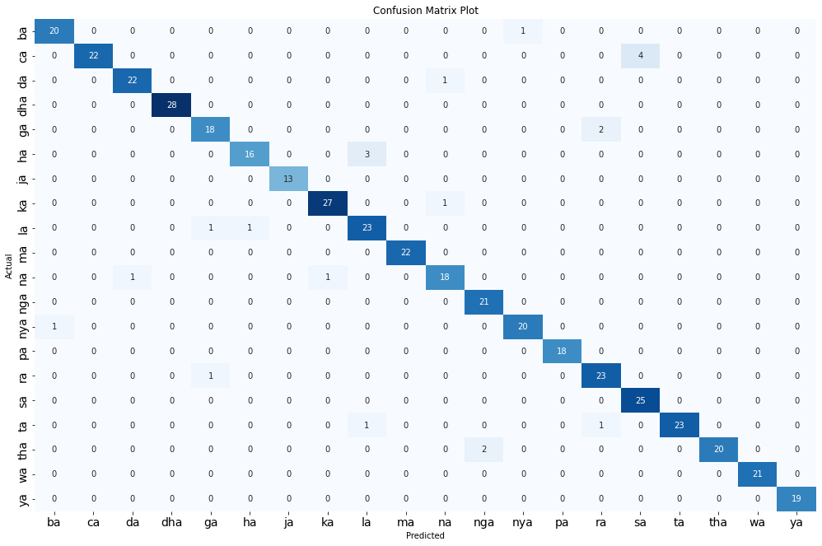

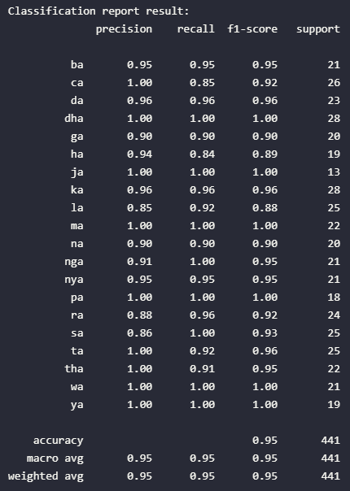

# Scenario 4

| **params** | **rank_test_score** | **mean_test_score** | **std_test_score** |
| --- | --- | --- | --- |
| **kernel** |  |  |  |  |
| 15_0.10508 | {'C': 15, 'gamma': 0.10508} | 1 | 0.919965 | 0.007521 |
| 6_0.10508 | {'C': 6, 'gamma': 0.10508} | 1 | 0.919965 | 0.007521 |
| 10_0.10508 | {'C': 10, 'gamma': 0.10508} | 1 | 0.919965 | 0.007521 |
| 3_0.10508 | {'C': 3, 'gamma': 0.10508} | 4 | 0.919164 | 0.007799 |
| 3_0.11384 | {'C': 3, 'gamma': 0.11384} | 5 | 0.918764 | 0.007266 |
| 15_0.11384 | {'C': 15, 'gamma': 0.11384} | 6 | 0.918364 | 0.007671 |
| 6_0.11384 | {'C': 6, 'gamma': 0.11384} | 6 | 0.918364 | 0.007671 |
| 6_0.10727 | {'C': 6, 'gamma': 0.10727} | 6 | 0.918364 | 0.007671 |
| 3_0.11165 | {'C': 3, 'gamma': 0.11165} | 6 | 0.918364 | 0.007352 |
| 10_0.11384 | {'C': 10, 'gamma': 0.11384} | 6 | 0.918364 | 0.007671 |
| 15_0.10727 | {'C': 15, 'gamma': 0.10727} | 6 | 0.918364 | 0.007671 |
| 10_0.10727 | {'C': 10, 'gamma': 0.10727} | 6 | 0.918364 | 0.007671 |
| 15_0.11165 | {'C': 15, 'gamma': 0.11165} | 13 | 0.917964 | 0.007732 |
| 6_0.11165 | {'C': 6, 'gamma': 0.11165} | 13 | 0.917964 | 0.007732 |
| 10_0.11165 | {'C': 10, 'gamma': 0.11165} | 13 | 0.917964 | 0.007732 |
| 3_0.10727 | {'C': 3, 'gamma': 0.10727} | 16 | 0.917963 | 0.008145 |
| 15_0.10946 | {'C': 15, 'gamma': 0.10946} | 17 | 0.917164 | 0.006803 |
| 6_0.10946 | {'C': 6, 'gamma': 0.10946} | 17 | 0.917164 | 0.006803 |
| 10_0.10946 | {'C': 10, 'gamma': 0.10946} | 17 | 0.917164 | 0.006803 |
| 3_0.10946 | {'C': 3, 'gamma': 0.10946} | 20 | 0.917163 | 0.007800 |
| 1_0.10946 | {'C': 1, 'gamma': 0.10946} | 21 | 0.905959 | 0.004966 |
| 1_0.10508 | {'C': 1, 'gamma': 0.10508} | 21 | 0.905959 | 0.004966 |
| 1_0.10727 | {'C': 1, 'gamma': 0.10727} | 23 | 0.905559 | 0.004698 |
| 1_0.11165 | {'C': 1, 'gamma': 0.11165} | 24 | 0.905558 | 0.005920 |
| 1_0.11384 | {'C': 1, 'gamma': 0.11384} | 25 | 0.904758 | 0.005523 |

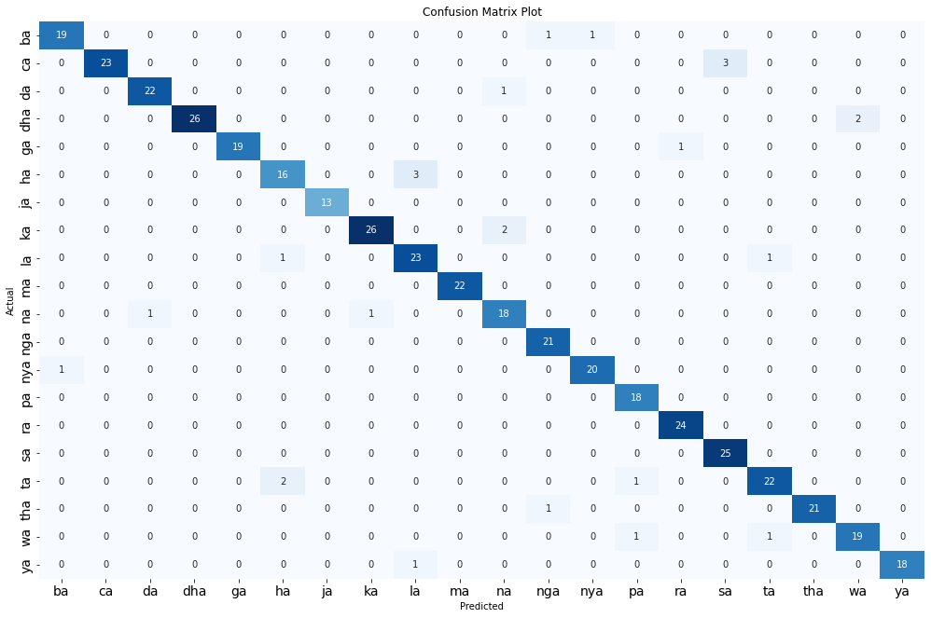

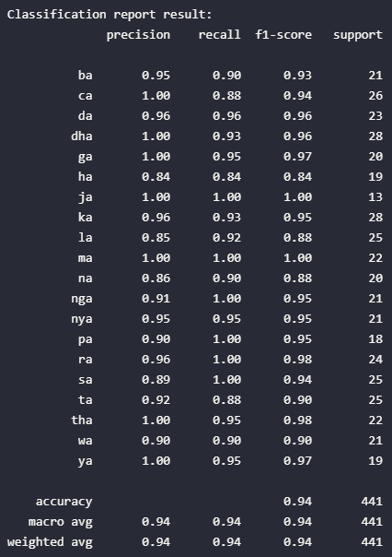

# Scenario 5

| **params** | **rank_test_score** | **mean_test_score** | **std_test_score** |
| --- | --- | --- | --- |
| **kernel** |  |  |  |  |
| 6_0.09522 | {'C': 6, 'gamma': 0.09522} | 1 | 0.912762 | 0.010200 |
| 15_0.09522 | {'C': 15, 'gamma': 0.09522} | 1 | 0.912762 | 0.010200 |
| 15_0.09142 | {'C': 15, 'gamma': 0.09142} | 1 | 0.912762 | 0.010200 |
| 10_0.09522 | {'C': 10, 'gamma': 0.09522} | 1 | 0.912762 | 0.010200 |
| 10_0.09142 | {'C': 10, 'gamma': 0.09142} | 1 | 0.912762 | 0.010200 |
| 6_0.09142 | {'C': 6, 'gamma': 0.09142} | 1 | 0.912762 | 0.010200 |
| 15_0.09332 | {'C': 15, 'gamma': 0.09332} | 7 | 0.912361 | 0.010577 |
| 10_0.09332 | {'C': 10, 'gamma': 0.09332} | 7 | 0.912361 | 0.010577 |
| 6_0.09332 | {'C': 6, 'gamma': 0.09332} | 7 | 0.912361 | 0.010577 |
| 10_0.09902 | {'C': 10, 'gamma': 0.09902} | 10 | 0.911962 | 0.009242 |
| 10_0.09712 | {'C': 10, 'gamma': 0.09712} | 10 | 0.911962 | 0.010460 |
| 6_0.09902 | {'C': 6, 'gamma': 0.09902} | 10 | 0.911962 | 0.009242 |
| 6_0.09712 | {'C': 6, 'gamma': 0.09712} | 10 | 0.911962 | 0.010460 |
| 15_0.09902 | {'C': 15, 'gamma': 0.09902} | 10 | 0.911962 | 0.009242 |
| 15_0.09712 | {'C': 15, 'gamma': 0.09712} | 10 | 0.911962 | 0.010460 |
| 3_0.09142 | {'C': 3, 'gamma': 0.09142} | 16 | 0.911561 | 0.009455 |
| 3_0.09522 | {'C': 3, 'gamma': 0.09522} | 17 | 0.910761 | 0.009553 |
| 3_0.09332 | {'C': 3, 'gamma': 0.09332} | 18 | 0.910360 | 0.009954 |
| 3_0.09902 | {'C': 3, 'gamma': 0.09902} | 19 | 0.909961 | 0.008428 |
| 3_0.09712 | {'C': 3, 'gamma': 0.09712} | 19 | 0.909961 | 0.009749 |
| 1_0.09142 | {'C': 1, 'gamma': 0.09142} | 21 | 0.899958 | 0.005976 |
| 1_0.09332 | {'C': 1, 'gamma': 0.09332} | 22 | 0.899157 | 0.005796 |
| 1_0.09522 | {'C': 1, 'gamma': 0.09522} | 23 | 0.898357 | 0.005622 |
| 1_0.09902 | {'C': 1, 'gamma': 0.09902} | 24 | 0.897557 | 0.005893 |
| 1_0.09712 | {'C': 1, 'gamma': 0.09712} | 24 | 0.897557 | 0.005323 |

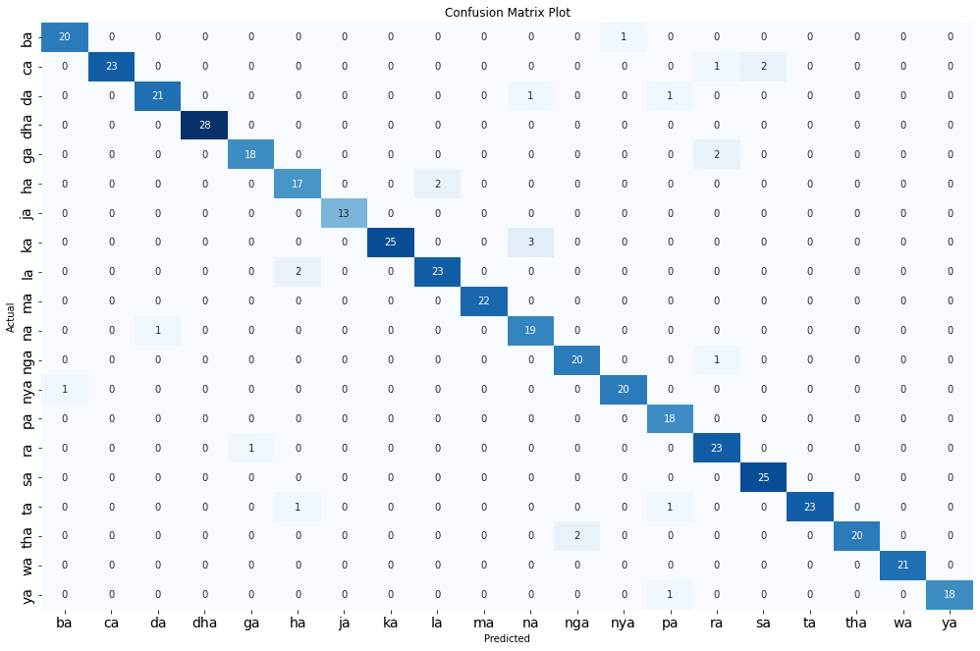

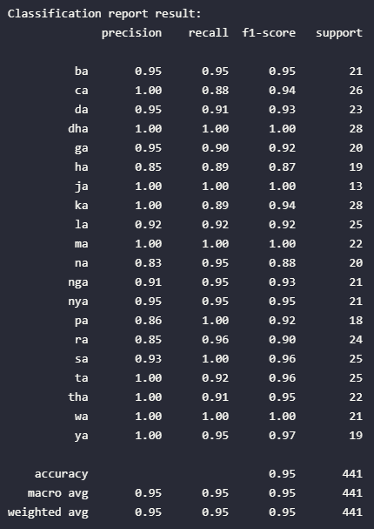

# Scenario 6

| **params** | **rank_test_score** | **mean_test_score** | **std_test_score** |
| --- | --- | --- | --- |
| **kernel** |  |  |  |  |
| 3_0.25495 | {'C': 3, 'gamma': 0.25495} | 1 | 0.890759 | 0.009570 |
| 6_0.25495 | {'C': 6, 'gamma': 0.25495} | 2 | 0.890358 | 0.007819 |
| 6_0.26557 | {'C': 6, 'gamma': 0.26557} | 3 | 0.889958 | 0.007979 |
| 6_0.26026 | {'C': 6, 'gamma': 0.26026} | 3 | 0.889958 | 0.006787 |
| 3_0.26557 | {'C': 3, 'gamma': 0.26557} | 5 | 0.889558 | 0.009639 |
| 3_0.26026 | {'C': 3, 'gamma': 0.26026} | 6 | 0.889158 | 0.009055 |
| 6_0.27088 | {'C': 6, 'gamma': 0.27088} | 7 | 0.889156 | 0.007752 |
| 6_0.27619 | {'C': 6, 'gamma': 0.27619} | 8 | 0.888756 | 0.009595 |
| 3_0.27619 | {'C': 3, 'gamma': 0.27619} | 9 | 0.888357 | 0.011042 |
| 3_0.27088 | {'C': 3, 'gamma': 0.27088} | 9 | 0.888357 | 0.009313 |
| 10_0.25495 | {'C': 10, 'gamma': 0.25495} | 11 | 0.888356 | 0.008325 |
| 10_0.26557 | {'C': 10, 'gamma': 0.26557} | 12 | 0.887956 | 0.008380 |
| 10_0.26026 | {'C': 10, 'gamma': 0.26026} | 12 | 0.887956 | 0.007144 |
| 15_0.25495 | {'C': 15, 'gamma': 0.25495} | 14 | 0.887956 | 0.008475 |
| 15_0.26026 | {'C': 15, 'gamma': 0.26026} | 15 | 0.887556 | 0.007296 |
| 15_0.26557 | {'C': 15, 'gamma': 0.26557} | 15 | 0.887556 | 0.008511 |
| 10_0.27619 | {'C': 10, 'gamma': 0.27619} | 17 | 0.887555 | 0.010149 |
| 15_0.27619 | {'C': 15, 'gamma': 0.27619} | 18 | 0.887155 | 0.010163 |
| 10_0.27088 | {'C': 10, 'gamma': 0.27088} | 19 | 0.887154 | 0.008359 |
| 15_0.27088 | {'C': 15, 'gamma': 0.27088} | 20 | 0.886754 | 0.008452 |
| 1_0.25495 | {'C': 1, 'gamma': 0.25495} | 21 | 0.881154 | 0.006746 |
| 1_0.26557 | {'C': 1, 'gamma': 0.26557} | 22 | 0.880754 | 0.006848 |
| 1_0.26026 | {'C': 1, 'gamma': 0.26026} | 23 | 0.880754 | 0.006121 |
| 1_0.27619 | {'C': 1, 'gamma': 0.27619} | 24 | 0.880354 | 0.007385 |
| 1_0.27088 | {'C': 1, 'gamma': 0.27088} | 24 | 0.880354 | 0.007276 |

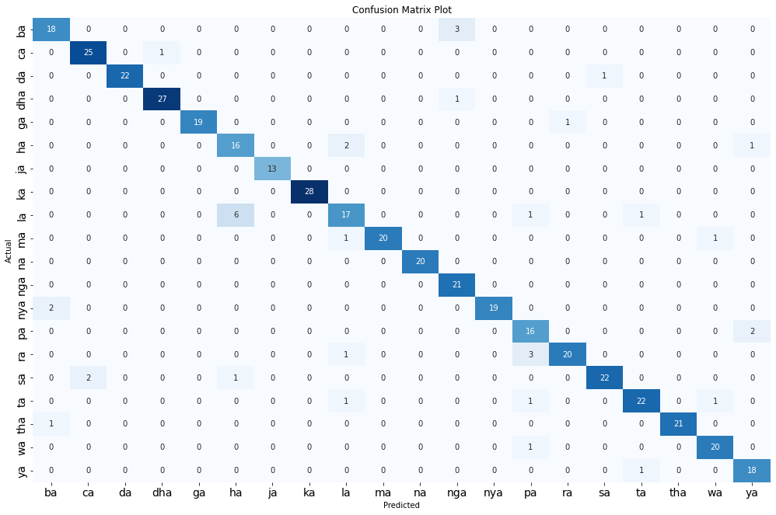

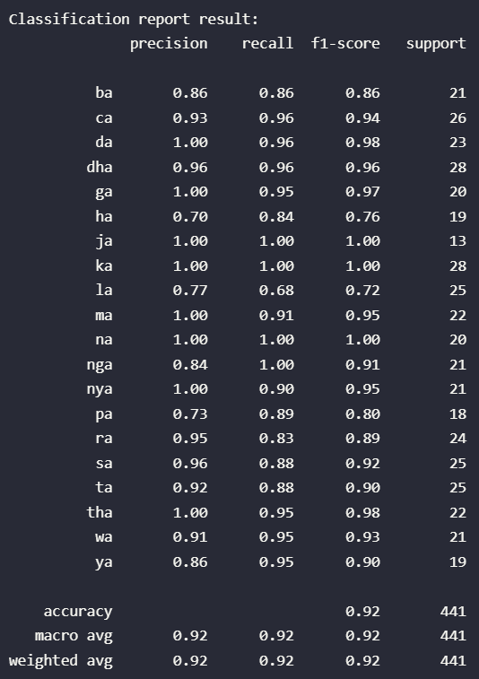

# Scenario 7

| **params** | **rank_test_score** | **mean_test_score** | **std_test_score** |
| --- | --- | --- | --- |
| **kernel** |  |  |  |  |
| 3_0.20533 | {'C': 3, 'gamma': 0.20533} | 1 | 0.899561 | 0.008128 |
| 3_0.20952 | {'C': 3, 'gamma': 0.20952} | 2 | 0.899162 | 0.007836 |
| 3_0.21371 | {'C': 3, 'gamma': 0.21371} | 3 | 0.897962 | 0.009271 |
| 3_0.2179 | {'C': 3, 'gamma': 0.2179} | 3 | 0.897962 | 0.008170 |
| 3_0.20114 | {'C': 3, 'gamma': 0.20114} | 5 | 0.897961 | 0.008080 |
| 15_0.20533 | {'C': 15, 'gamma': 0.20533} | 6 | 0.897562 | 0.009209 |
| 10_0.20533 | {'C': 10, 'gamma': 0.20533} | 6 | 0.897562 | 0.009209 |
| 6_0.20533 | {'C': 6, 'gamma': 0.20533} | 8 | 0.897562 | 0.009042 |
| 15_0.20952 | {'C': 15, 'gamma': 0.20952} | 9 | 0.896762 | 0.008779 |
| 10_0.20952 | {'C': 10, 'gamma': 0.20952} | 9 | 0.896762 | 0.008779 |
| 15_0.2179 | {'C': 15, 'gamma': 0.2179} | 11 | 0.896762 | 0.009730 |
| 10_0.2179 | {'C': 10, 'gamma': 0.2179} | 11 | 0.896762 | 0.009730 |
| 6_0.2179 | {'C': 6, 'gamma': 0.2179} | 13 | 0.896762 | 0.009487 |
| 6_0.20952 | {'C': 6, 'gamma': 0.20952} | 13 | 0.896762 | 0.008603 |
| 10_0.20114 | {'C': 10, 'gamma': 0.20114} | 15 | 0.896362 | 0.008667 |
| 15_0.20114 | {'C': 15, 'gamma': 0.20114} | 15 | 0.896362 | 0.008667 |
| 6_0.20114 | {'C': 6, 'gamma': 0.20114} | 17 | 0.896362 | 0.008394 |
| 15_0.21371 | {'C': 15, 'gamma': 0.21371} | 18 | 0.895962 | 0.010318 |
| 10_0.21371 | {'C': 10, 'gamma': 0.21371} | 18 | 0.895962 | 0.010318 |
| 6_0.21371 | {'C': 6, 'gamma': 0.21371} | 20 | 0.895962 | 0.010168 |
| 1_0.2179 | {'C': 1, 'gamma': 0.2179} | 21 | 0.892360 | 0.006696 |
| 1_0.21371 | {'C': 1, 'gamma': 0.21371} | 22 | 0.891160 | 0.008016 |
| 1_0.20952 | {'C': 1, 'gamma': 0.20952} | 22 | 0.891160 | 0.008016 |
| 1_0.20533 | {'C': 1, 'gamma': 0.20533} | 22 | 0.891160 | 0.008016 |
| 1_0.20114 | {'C': 1, 'gamma': 0.20114} | 25 | 0.890759 | 0.007614 |

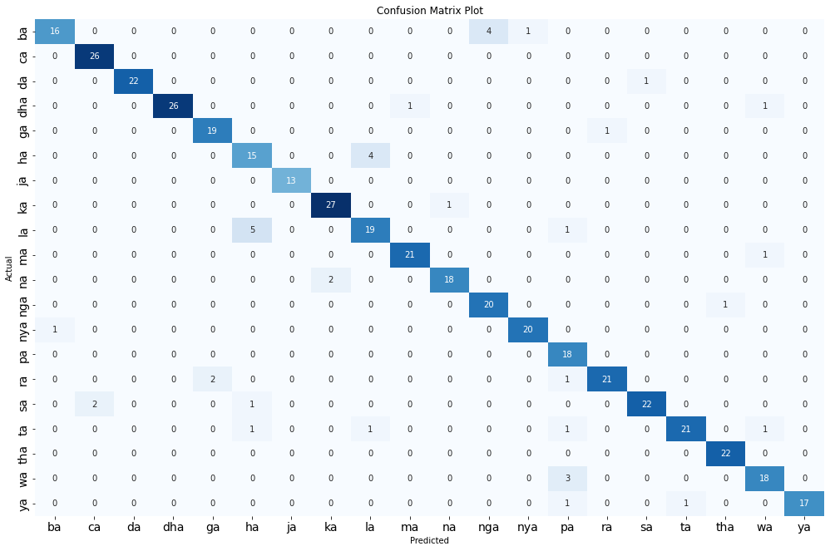

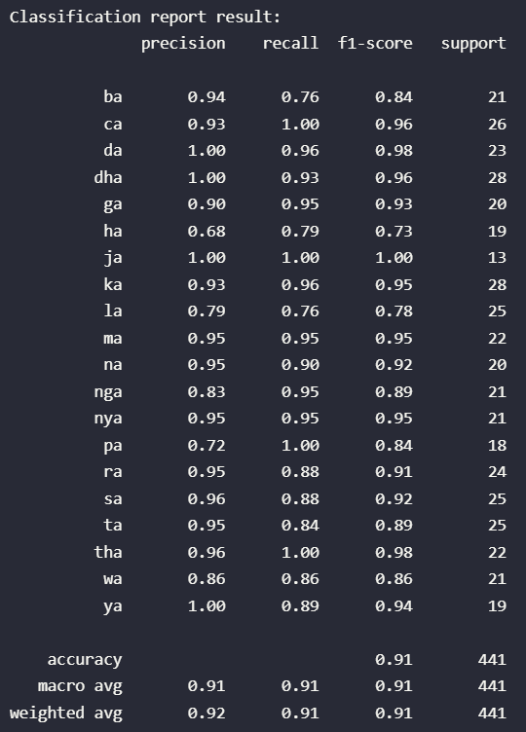

# Scenario 8

| **params** | **rank_test_score** | **mean_test_score** | **std_test_score** |
| --- | --- | --- | --- |
| **kernel** |  |  |  |  |
| 6_0.13022 | {'C': 6, 'gamma': 0.13022} | 1 | 0.906367 | 0.009873 |
| 6_0.13293 | {'C': 6, 'gamma': 0.13293} | 2 | 0.905567 | 0.009871 |
| 15_0.13022 | {'C': 15, 'gamma': 0.13022} | 3 | 0.905167 | 0.010437 |
| 10_0.13022 | {'C': 10, 'gamma': 0.13022} | 3 | 0.905167 | 0.010437 |
| 6_0.13564 | {'C': 6, 'gamma': 0.13564} | 5 | 0.904767 | 0.010738 |
| 6_0.13835 | {'C': 6, 'gamma': 0.13835} | 6 | 0.904766 | 0.009809 |
| 15_0.13293 | {'C': 15, 'gamma': 0.13293} | 7 | 0.904367 | 0.010342 |
| 10_0.13293 | {'C': 10, 'gamma': 0.13293} | 7 | 0.904367 | 0.010342 |
| 6_0.14106 | {'C': 6, 'gamma': 0.14106} | 9 | 0.904366 | 0.010430 |
| 15_0.13564 | {'C': 15, 'gamma': 0.13564} | 10 | 0.903567 | 0.011229 |
| 10_0.13564 | {'C': 10, 'gamma': 0.13564} | 10 | 0.903567 | 0.011229 |
| 10_0.13835 | {'C': 10, 'gamma': 0.13835} | 12 | 0.903566 | 0.010267 |
| 15_0.13835 | {'C': 15, 'gamma': 0.13835} | 12 | 0.903566 | 0.010267 |
| 10_0.14106 | {'C': 10, 'gamma': 0.14106} | 14 | 0.903566 | 0.010504 |
| 15_0.14106 | {'C': 15, 'gamma': 0.14106} | 14 | 0.903566 | 0.010504 |
| 3_0.13022 | {'C': 3, 'gamma': 0.13022} | 16 | 0.903166 | 0.009721 |
| 3_0.14106 | {'C': 3, 'gamma': 0.14106} | 17 | 0.903166 | 0.010051 |
| 3_0.13835 | {'C': 3, 'gamma': 0.13835} | 18 | 0.902766 | 0.009219 |
| 3_0.13564 | {'C': 3, 'gamma': 0.13564} | 19 | 0.902366 | 0.010026 |
| 3_0.13293 | {'C': 3, 'gamma': 0.13293} | 19 | 0.902366 | 0.009366 |
| 1_0.13293 | {'C': 1, 'gamma': 0.13293} | 21 | 0.899962 | 0.006896 |
| 1_0.13564 | {'C': 1, 'gamma': 0.13564} | 22 | 0.899562 | 0.006824 |
| 1_0.13022 | {'C': 1, 'gamma': 0.13022} | 22 | 0.899562 | 0.006824 |
| 1_0.14106 | {'C': 1, 'gamma': 0.14106} | 24 | 0.899562 | 0.007714 |
| 1_0.13835 | {'C': 1, 'gamma': 0.13835} | 25 | 0.898762 | 0.007083 |

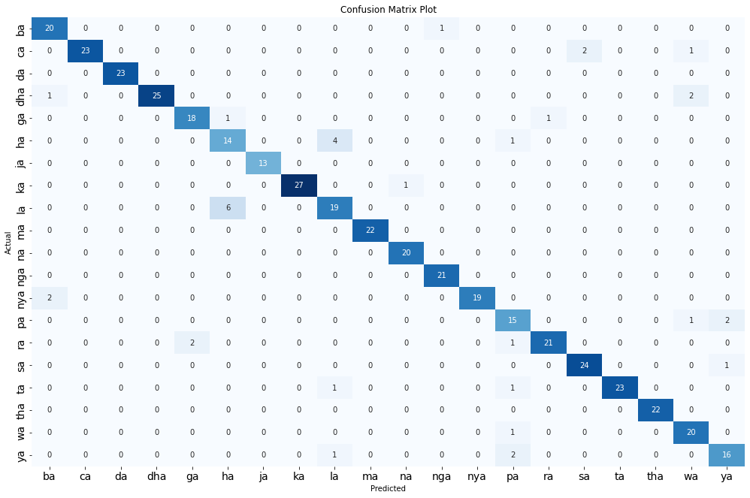

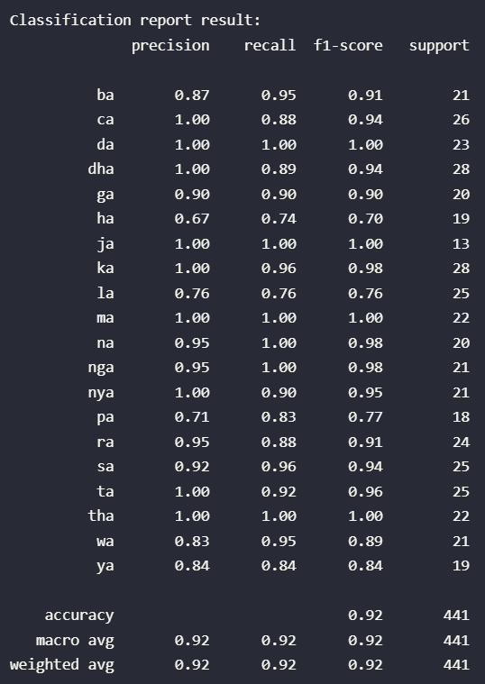

# Scenario 9

| **params** | **rank_test_score** | **mean_test_score** | **std_test_score** |
| --- | --- | --- | --- |
| **kernel** |  |  |  |  |
| 15_0.10009 | {'C': 15, 'gamma': 0.10009} | 1 | 0.907967 | 0.009765 |
| 10_0.10009 | {'C': 10, 'gamma': 0.10009} | 1 | 0.907967 | 0.009765 |
| 6_0.10009 | {'C': 6, 'gamma': 0.10009} | 1 | 0.907967 | 0.009765 |
| 15_0.10217 | {'C': 15, 'gamma': 0.10217} | 4 | 0.907567 | 0.009631 |
| 10_0.10217 | {'C': 10, 'gamma': 0.10217} | 4 | 0.907567 | 0.009631 |
| 6_0.10217 | {'C': 6, 'gamma': 0.10217} | 4 | 0.907567 | 0.009631 |
| 6_0.10425 | {'C': 6, 'gamma': 0.10425} | 7 | 0.907167 | 0.009729 |
| 15_0.10425 | {'C': 15, 'gamma': 0.10425} | 7 | 0.907167 | 0.009729 |
| 10_0.10841 | {'C': 10, 'gamma': 0.10841} | 7 | 0.907167 | 0.010595 |
| 10_0.10633 | {'C': 10, 'gamma': 0.10633} | 7 | 0.907167 | 0.009729 |
| 10_0.10425 | {'C': 10, 'gamma': 0.10425} | 7 | 0.907167 | 0.009729 |
| 6_0.10841 | {'C': 6, 'gamma': 0.10841} | 7 | 0.907167 | 0.010595 |
| 6_0.10633 | {'C': 6, 'gamma': 0.10633} | 7 | 0.907167 | 0.009729 |
| 15_0.10841 | {'C': 15, 'gamma': 0.10841} | 7 | 0.907167 | 0.010595 |
| 15_0.10633 | {'C': 15, 'gamma': 0.10633} | 7 | 0.907167 | 0.009729 |
| 3_0.10841 | {'C': 3, 'gamma': 0.10841} | 16 | 0.906367 | 0.012062 |
| 3_0.10633 | {'C': 3, 'gamma': 0.10633} | 17 | 0.905967 | 0.011900 |
| 3_0.10217 | {'C': 3, 'gamma': 0.10217} | 17 | 0.905967 | 0.011628 |
| 3_0.10009 | {'C': 3, 'gamma': 0.10009} | 17 | 0.905967 | 0.011628 |
| 3_0.10425 | {'C': 3, 'gamma': 0.10425} | 20 | 0.905567 | 0.011655 |
| 1_0.10425 | {'C': 1, 'gamma': 0.10425} | 21 | 0.891157 | 0.010320 |
| 1_0.10009 | {'C': 1, 'gamma': 0.10009} | 21 | 0.891157 | 0.009925 |
| 1_0.10841 | {'C': 1, 'gamma': 0.10841} | 23 | 0.890756 | 0.010012 |
| 1_0.10633 | {'C': 1, 'gamma': 0.10633} | 23 | 0.890756 | 0.010012 |
| 1_0.10217 | {'C': 1, 'gamma': 0.10217} | 25 | 0.890357 | 0.009660 |

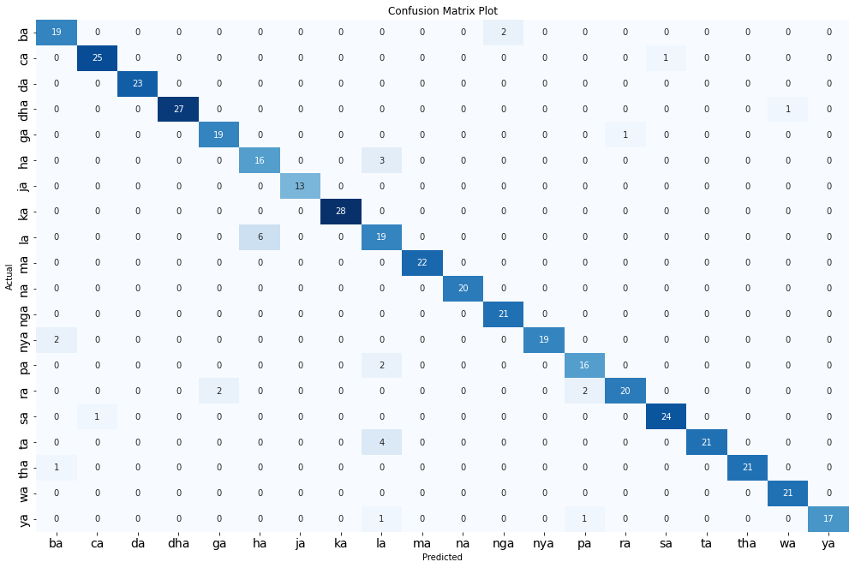

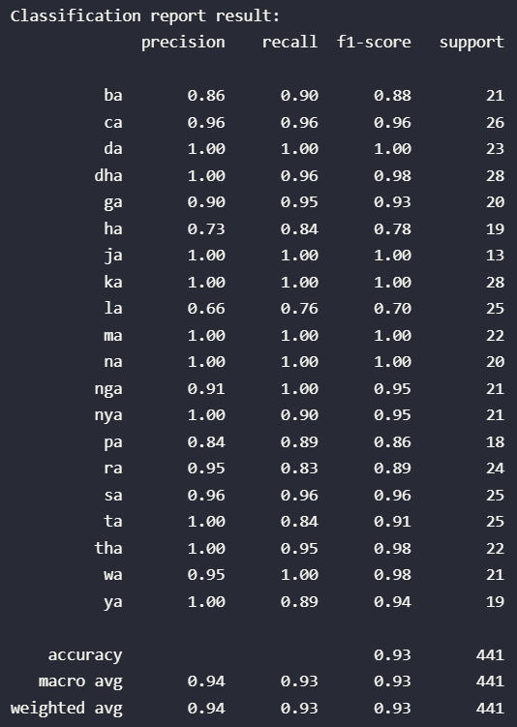

# Scenario 10

| **params** | **rank_test_score** | **mean_test_score** | **std_test_score** |
| --- | --- | --- | --- |
| **kernel** |  |  |  |  |
| 3_0.08725 | {'C': 3, 'gamma': 0.08725} | 1 | 0.900761 | 0.011699 |
| 6_0.08725 | {'C': 6, 'gamma': 0.08725} | 2 | 0.900361 | 0.010978 |
| 10_0.08725 | {'C': 10, 'gamma': 0.08725} | 3 | 0.899961 | 0.011020 |
| 15_0.08725 | {'C': 15, 'gamma': 0.08725} | 3 | 0.899961 | 0.011020 |
| 6_0.08907 | {'C': 6, 'gamma': 0.08907} | 5 | 0.899560 | 0.012092 |
| 6_0.09089 | {'C': 6, 'gamma': 0.09089} | 6 | 0.899559 | 0.012099 |
| 6_0.09271 | {'C': 6, 'gamma': 0.09271} | 6 | 0.899559 | 0.012099 |
| 3_0.09271 | {'C': 3, 'gamma': 0.09271} | 6 | 0.899559 | 0.013235 |
| 3_0.08907 | {'C': 3, 'gamma': 0.08907} | 6 | 0.899559 | 0.012868 |
| 3_0.09089 | {'C': 3, 'gamma': 0.09089} | 6 | 0.899559 | 0.012868 |
| 10_0.08907 | {'C': 10, 'gamma': 0.08907} | 11 | 0.899160 | 0.012170 |
| 15_0.08907 | {'C': 15, 'gamma': 0.08907} | 11 | 0.899160 | 0.012170 |
| 10_0.09271 | {'C': 10, 'gamma': 0.09271} | 13 | 0.899159 | 0.012111 |
| 15_0.09271 | {'C': 15, 'gamma': 0.09271} | 13 | 0.899159 | 0.012111 |
| 6_0.09453 | {'C': 6, 'gamma': 0.09453} | 13 | 0.899159 | 0.011361 |
| 15_0.09089 | {'C': 15, 'gamma': 0.09089} | 13 | 0.899159 | 0.012111 |
| 10_0.09089 | {'C': 10, 'gamma': 0.09089} | 13 | 0.899159 | 0.012111 |
| 10_0.09453 | {'C': 10, 'gamma': 0.09453} | 18 | 0.898759 | 0.011359 |
| 15_0.09453 | {'C': 15, 'gamma': 0.09453} | 18 | 0.898759 | 0.011359 |
| 3_0.09453 | {'C': 3, 'gamma': 0.09453} | 18 | 0.898759 | 0.011774 |
| 1_0.08725 | {'C': 1, 'gamma': 0.08725} | 21 | 0.892759 | 0.006851 |
| 1_0.09089 | {'C': 1, 'gamma': 0.09089} | 22 | 0.891959 | 0.008736 |
| 1_0.08907 | {'C': 1, 'gamma': 0.08907} | 22 | 0.891959 | 0.008736 |
| 1_0.09271 | {'C': 1, 'gamma': 0.09271} | 24 | 0.891958 | 0.008079 |
| 1_0.09453 | {'C': 1, 'gamma': 0.09453} | 25 | 0.891158 | 0.008976 |

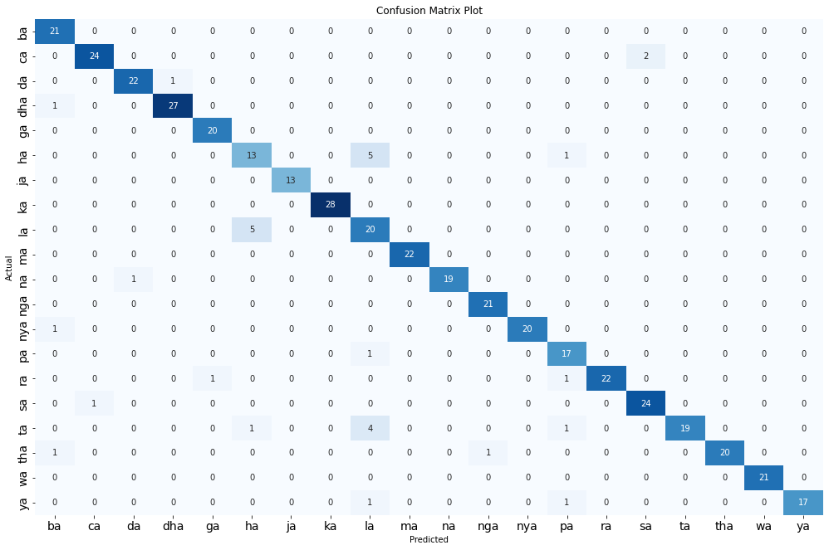

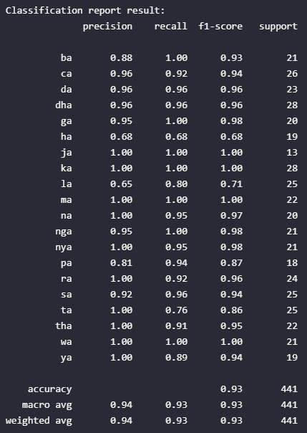

# Scenario 11

| **params** | **rank_test_score** | **mean_test_score** | **std_test_score** |
| --- | --- | --- | --- |
| **kernel** |  |  |  |  |
| 3_0.26821 | {'C': 3, 'gamma': 0.26821} | 1 | 0.884762 | 0.012750 |
| 3_0.27368 | {'C': 3, 'gamma': 0.27368} | 1 | 0.884762 | 0.012750 |
| 3_0.27915 | {'C': 3, 'gamma': 0.27915} | 1 | 0.884762 | 0.012561 |
| 6_0.27915 | {'C': 6, 'gamma': 0.27915} | 4 | 0.883962 | 0.012196 |
| 3_0.28462 | {'C': 3, 'gamma': 0.28462} | 5 | 0.883962 | 0.012456 |
| 3_0.26274 | {'C': 3, 'gamma': 0.26274} | 6 | 0.883962 | 0.011869 |
| 6_0.27368 | {'C': 6, 'gamma': 0.27368} | 7 | 0.883562 | 0.012286 |
| 6_0.28462 | {'C': 6, 'gamma': 0.28462} | 8 | 0.883162 | 0.012167 |
| 6_0.26821 | {'C': 6, 'gamma': 0.26821} | 9 | 0.882762 | 0.012681 |
| 15_0.27368 | {'C': 15, 'gamma': 0.27368} | 10 | 0.882761 | 0.011147 |
| 10_0.27915 | {'C': 10, 'gamma': 0.27915} | 10 | 0.882761 | 0.011147 |
| 15_0.27915 | {'C': 15, 'gamma': 0.27915} | 10 | 0.882761 | 0.011147 |
| 10_0.27368 | {'C': 10, 'gamma': 0.27368} | 10 | 0.882761 | 0.011147 |
| 6_0.26274 | {'C': 6, 'gamma': 0.26274} | 14 | 0.881962 | 0.012129 |
| 15_0.26821 | {'C': 15, 'gamma': 0.26821} | 15 | 0.881961 | 0.011456 |
| 10_0.28462 | {'C': 10, 'gamma': 0.28462} | 15 | 0.881961 | 0.011029 |
| 15_0.28462 | {'C': 15, 'gamma': 0.28462} | 15 | 0.881961 | 0.011029 |
| 10_0.26821 | {'C': 10, 'gamma': 0.26821} | 15 | 0.881961 | 0.011456 |
| 10_0.26274 | {'C': 10, 'gamma': 0.26274} | 19 | 0.881561 | 0.011621 |
| 15_0.26274 | {'C': 15, 'gamma': 0.26274} | 20 | 0.881160 | 0.010930 |
| 1_0.28462 | {'C': 1, 'gamma': 0.28462} | 21 | 0.879162 | 0.014274 |
| 1_0.27368 | {'C': 1, 'gamma': 0.27368} | 21 | 0.879162 | 0.014274 |
| 1_0.27915 | {'C': 1, 'gamma': 0.27915} | 23 | 0.878762 | 0.014385 |
| 1_0.26821 | {'C': 1, 'gamma': 0.26821} | 23 | 0.878762 | 0.014550 |
| 1_0.26274 | {'C': 1, 'gamma': 0.26274} | 25 | 0.878362 | 0.014593 |

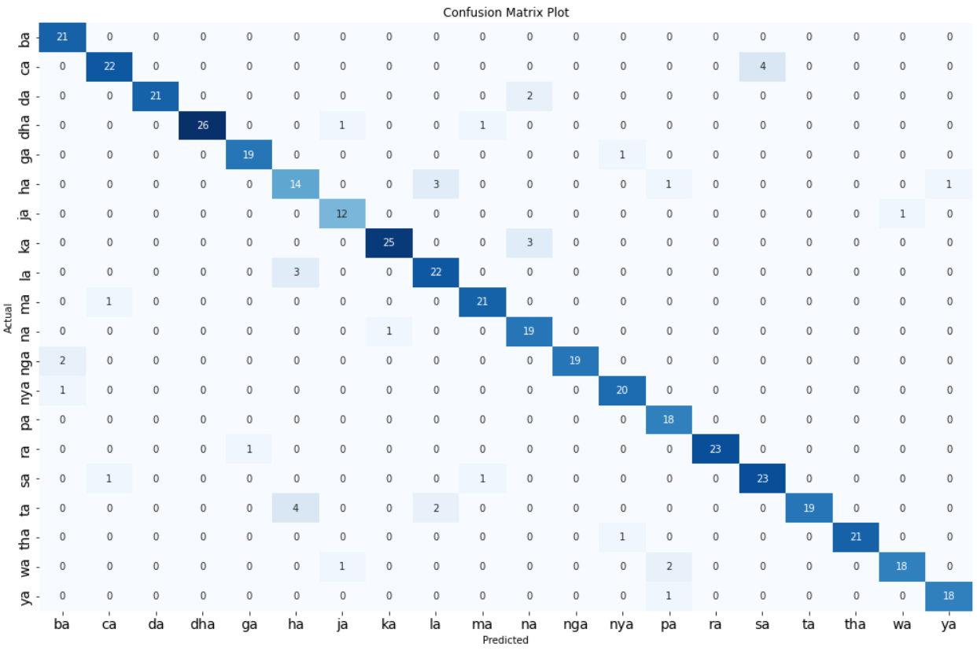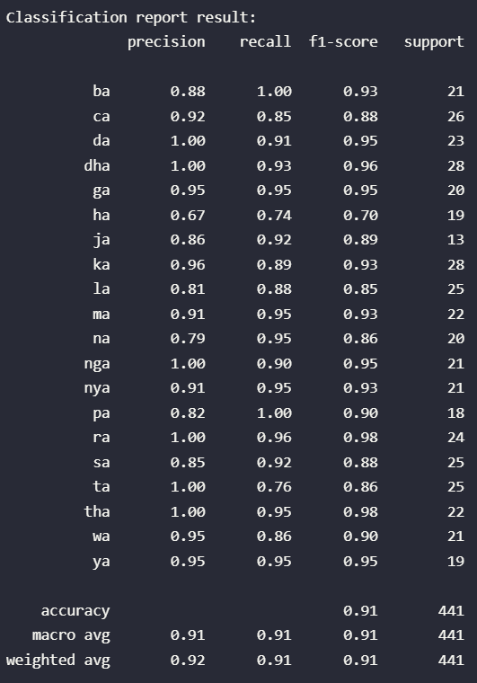

# Scenario 12

| **params** | **rank_test_score** | **mean_test_score** | **std_test_score** |
| --- | --- | --- | --- |
| **kernel** |  |  |  |  |
| 3_0.20183 | {'C': 3, 'gamma': 0.20183} | 1 | 0.909166 | 0.011960 |
| 3_0.21023 | {'C': 3, 'gamma': 0.21023} | 2 | 0.908766 | 0.011270 |
| 3_0.20603 | {'C': 3, 'gamma': 0.20603} | 2 | 0.908766 | 0.012092 |
| 3_0.21443 | {'C': 3, 'gamma': 0.21443} | 4 | 0.907966 | 0.011153 |
| 3_0.21863 | {'C': 3, 'gamma': 0.21863} | 4 | 0.907966 | 0.011153 |
| 6_0.20183 | {'C': 6, 'gamma': 0.20183} | 6 | 0.907565 | 0.015031 |
| 6_0.21863 | {'C': 6, 'gamma': 0.21863} | 7 | 0.907166 | 0.014495 |
| 6_0.21023 | {'C': 6, 'gamma': 0.21023} | 8 | 0.907165 | 0.014609 |
| 10_0.20183 | {'C': 10, 'gamma': 0.20183} | 9 | 0.907163 | 0.013889 |
| 6_0.20603 | {'C': 6, 'gamma': 0.20603} | 10 | 0.906765 | 0.015614 |
| 6_0.21443 | {'C': 6, 'gamma': 0.21443} | 10 | 0.906765 | 0.014332 |
| 10_0.20603 | {'C': 10, 'gamma': 0.20603} | 12 | 0.906363 | 0.014440 |
| 10_0.21023 | {'C': 10, 'gamma': 0.21023} | 12 | 0.906363 | 0.013701 |
| 15_0.20183 | {'C': 15, 'gamma': 0.20183} | 14 | 0.906362 | 0.014109 |
| 10_0.21443 | {'C': 10, 'gamma': 0.21443} | 15 | 0.905563 | 0.013582 |
| 10_0.21863 | {'C': 10, 'gamma': 0.21863} | 15 | 0.905563 | 0.013582 |
| 15_0.20603 | {'C': 15, 'gamma': 0.20603} | 17 | 0.905562 | 0.014609 |
| 15_0.21023 | {'C': 15, 'gamma': 0.21023} | 17 | 0.905562 | 0.013879 |
| 15_0.21863 | {'C': 15, 'gamma': 0.21863} | 19 | 0.905162 | 0.013539 |
| 15_0.21443 | {'C': 15, 'gamma': 0.21443} | 19 | 0.905162 | 0.013539 |
| 1_0.21443 | {'C': 1, 'gamma': 0.21443} | 21 | 0.900366 | 0.011916 |
| 1_0.21023 | {'C': 1, 'gamma': 0.21023} | 22 | 0.900366 | 0.011921 |
| 1_0.20183 | {'C': 1, 'gamma': 0.20183} | 23 | 0.900365 | 0.011447 |
| 1_0.21863 | {'C': 1, 'gamma': 0.21863} | 24 | 0.899966 | 0.012220 |
| 1_0.20603 | {'C': 1, 'gamma': 0.20603} | 25 | 0.899565 | 0.011856 |

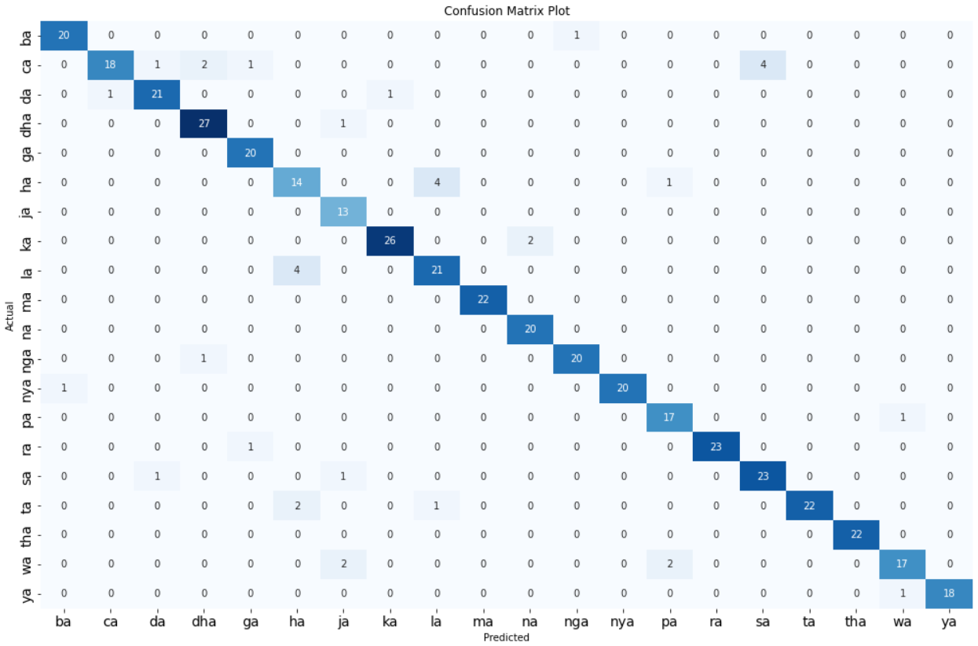

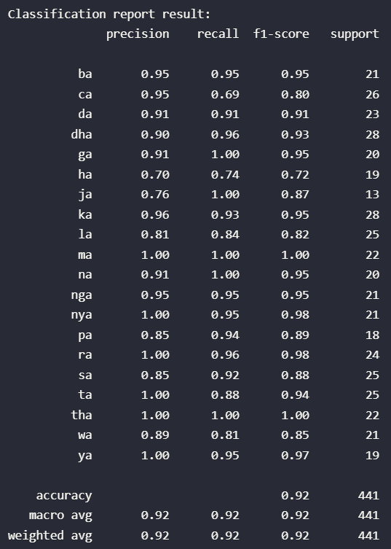

# Scenario 13

| **params** | **rank_test_score** | **mean_test_score** | **std_test_score** |
| --- | --- | --- | --- |
| **kernel** |  |  |  |  |
| 3_0.13196 | {'C': 3, 'gamma': 0.13196} | 1 | 0.918374 | 0.010795 |
| 3_0.1346 | {'C': 3, 'gamma': 0.1346} | 1 | 0.918374 | 0.010795 |
| 6_0.13724 | {'C': 6, 'gamma': 0.13724} | 3 | 0.918374 | 0.010498 |
| 15_0.13724 | {'C': 15, 'gamma': 0.13724} | 4 | 0.917974 | 0.011134 |
| 10_0.13724 | {'C': 10, 'gamma': 0.13724} | 4 | 0.917974 | 0.011134 |
| 3_0.13724 | {'C': 3, 'gamma': 0.13724} | 4 | 0.917974 | 0.010313 |
| 6_0.1346 | {'C': 6, 'gamma': 0.1346} | 7 | 0.917574 | 0.010420 |
| 10_0.1346 | {'C': 10, 'gamma': 0.1346} | 8 | 0.917174 | 0.011031 |
| 15_0.1346 | {'C': 15, 'gamma': 0.1346} | 8 | 0.917174 | 0.011031 |
| 6_0.13196 | {'C': 6, 'gamma': 0.13196} | 8 | 0.917174 | 0.011031 |
| 10_0.13196 | {'C': 10, 'gamma': 0.13196} | 11 | 0.916774 | 0.011664 |
| 15_0.13196 | {'C': 15, 'gamma': 0.13196} | 11 | 0.916774 | 0.011664 |
| 6_0.12668 | {'C': 6, 'gamma': 0.12668} | 13 | 0.916774 | 0.010356 |
| 3_0.12932 | {'C': 3, 'gamma': 0.12932} | 13 | 0.916774 | 0.010884 |
| 6_0.12932 | {'C': 6, 'gamma': 0.12932} | 15 | 0.916374 | 0.010941 |
| 10_0.12668 | {'C': 10, 'gamma': 0.12668} | 15 | 0.916374 | 0.010941 |
| 15_0.12668 | {'C': 15, 'gamma': 0.12668} | 15 | 0.916374 | 0.010941 |
| 3_0.12668 | {'C': 3, 'gamma': 0.12668} | 18 | 0.916373 | 0.010266 |
| 10_0.12932 | {'C': 10, 'gamma': 0.12932} | 19 | 0.915974 | 0.011552 |
| 15_0.12932 | {'C': 15, 'gamma': 0.12932} | 19 | 0.915974 | 0.011552 |
| 1_0.13724 | {'C': 1, 'gamma': 0.13724} | 21 | 0.906370 | 0.010410 |
| 1_0.1346 | {'C': 1, 'gamma': 0.1346} | 22 | 0.906369 | 0.009448 |
| 1_0.13196 | {'C': 1, 'gamma': 0.13196} | 23 | 0.905969 | 0.009413 |
| 1_0.12668 | {'C': 1, 'gamma': 0.12668} | 24 | 0.905169 | 0.010115 |
| 1_0.12932 | {'C': 1, 'gamma': 0.12932} | 25 | 0.904769 | 0.010193 |

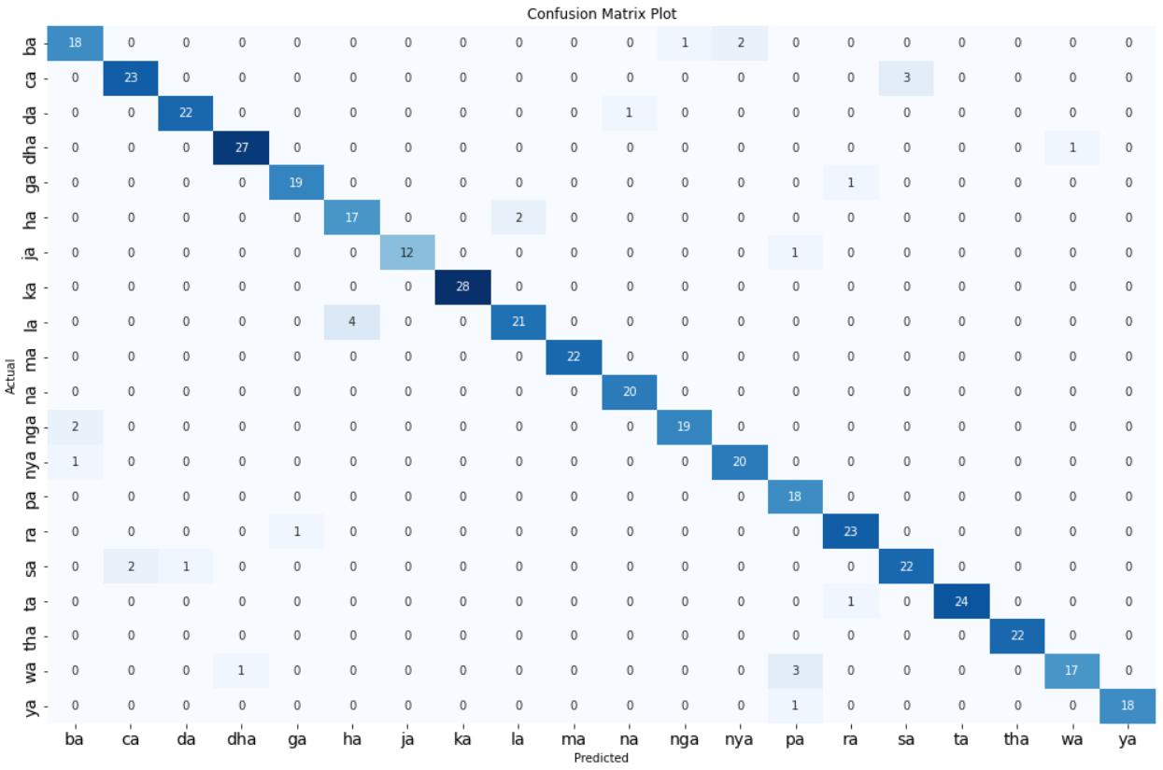

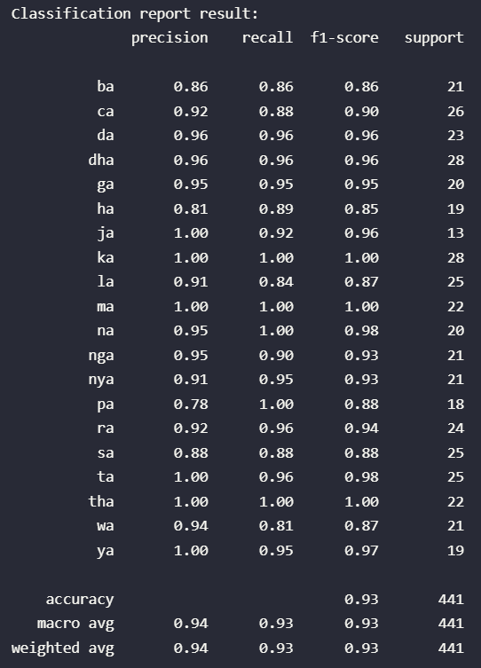

# Scenario 14

| **params** | **rank_test_score** | **mean_test_score** | **std_test_score** |
| --- | --- | --- | --- |
| **kernel** |  |  |  |  |
| 15_0.10234 | {'C': 15, 'gamma': 0.10234} | 1 | 0.921174 | 0.012012 |
| 10_0.10234 | {'C': 10, 'gamma': 0.10234} | 1 | 0.921174 | 0.012012 |
| 6_0.10234 | {'C': 6, 'gamma': 0.10234} | 1 | 0.921174 | 0.012012 |
| 6_0.1066 | {'C': 6, 'gamma': 0.1066} | 4 | 0.920774 | 0.011605 |
| 15_0.1066 | {'C': 15, 'gamma': 0.1066} | 4 | 0.920774 | 0.011605 |
| 15_0.10447 | {'C': 15, 'gamma': 0.10447} | 4 | 0.920774 | 0.011605 |
| 10_0.1066 | {'C': 10, 'gamma': 0.1066} | 4 | 0.920774 | 0.011605 |
| 10_0.10447 | {'C': 10, 'gamma': 0.10447} | 4 | 0.920774 | 0.011605 |
| 6_0.10447 | {'C': 6, 'gamma': 0.10447} | 4 | 0.920774 | 0.011605 |
| 10_0.10873 | {'C': 10, 'gamma': 0.10873} | 10 | 0.920373 | 0.011172 |
| 15_0.10873 | {'C': 15, 'gamma': 0.10873} | 10 | 0.920373 | 0.011172 |
| 6_0.10873 | {'C': 6, 'gamma': 0.10873} | 10 | 0.920373 | 0.011172 |
| 10_0.11086 | {'C': 10, 'gamma': 0.11086} | 13 | 0.919573 | 0.011999 |
| 6_0.11086 | {'C': 6, 'gamma': 0.11086} | 13 | 0.919573 | 0.011999 |
| 15_0.11086 | {'C': 15, 'gamma': 0.11086} | 13 | 0.919573 | 0.011999 |
| 3_0.1066 | {'C': 3, 'gamma': 0.1066} | 16 | 0.919174 | 0.012968 |
| 3_0.10234 | {'C': 3, 'gamma': 0.10234} | 16 | 0.919174 | 0.013273 |
| 3_0.10447 | {'C': 3, 'gamma': 0.10447} | 18 | 0.918774 | 0.012906 |
| 3_0.10873 | {'C': 3, 'gamma': 0.10873} | 19 | 0.918773 | 0.012532 |
| 3_0.11086 | {'C': 3, 'gamma': 0.11086} | 20 | 0.917973 | 0.013418 |
| 1_0.1066 | {'C': 1, 'gamma': 0.1066} | 21 | 0.906366 | 0.016346 |
| 1_0.10447 | {'C': 1, 'gamma': 0.10447} | 21 | 0.906366 | 0.016346 |
| 1_0.10234 | {'C': 1, 'gamma': 0.10234} | 23 | 0.905566 | 0.016636 |
| 1_0.10873 | {'C': 1, 'gamma': 0.10873} | 24 | 0.905166 | 0.016792 |
| 1_0.11086 | {'C': 1, 'gamma': 0.11086} | 25 | 0.904766 | 0.016980 |

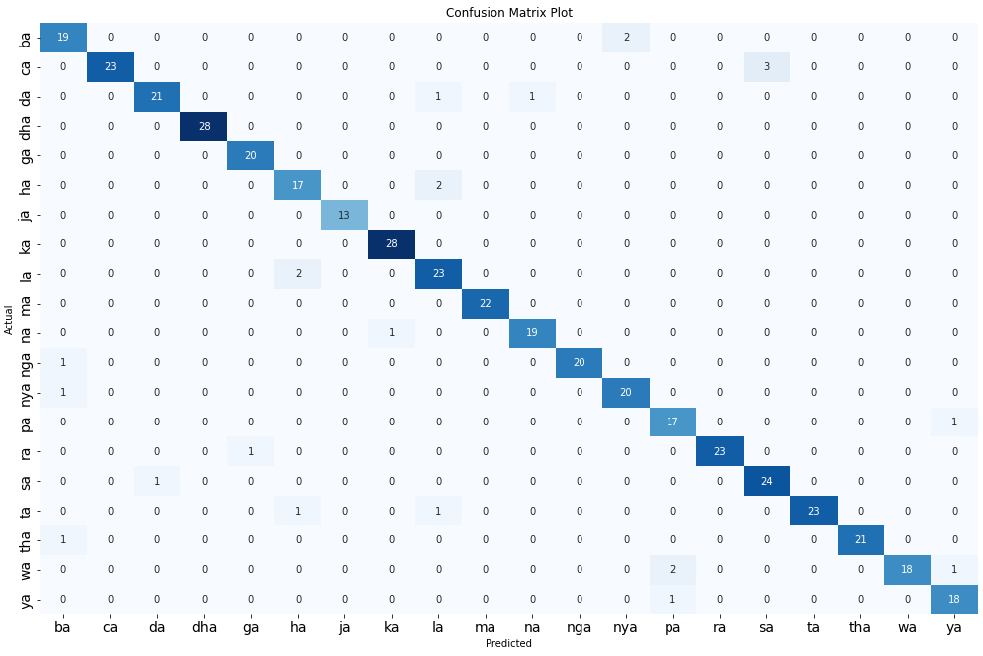

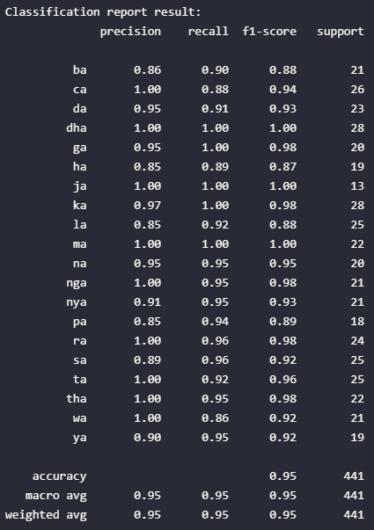

# Scenario 15

| **params** | **rank_test_score** | **mean_test_score** | **std_test_score** |
| --- | --- | --- | --- |
| **kernel** |  |  |  |  |
| 6_0.021 | {'C': 6, 'gamma': 0.021} | 1 | 0.512209 | 0.013956 |
| 6_0.018 | {'C': 6, 'gamma': 0.018} | 2 | 0.512208 | 0.015161 |
| 15_0.018 | {'C': 15, 'gamma': 0.018} | 3 | 0.511806 | 0.014649 |
| 15_0.021 | {'C': 15, 'gamma': 0.021} | 4 | 0.511409 | 0.014059 |
| 10_0.021 | {'C': 10, 'gamma': 0.021} | 4 | 0.511409 | 0.014059 |
| 10_0.018 | {'C': 10, 'gamma': 0.018} | 6 | 0.511406 | 0.014989 |
| 3_0.021 | {'C': 3, 'gamma': 0.021} | 7 | 0.511008 | 0.012336 |
| 3_0.018 | {'C': 3, 'gamma': 0.018} | 8 | 0.510610 | 0.013803 |
| 3_scale | {'C': 3, 'gamma': 'scale'} | 9 | 0.510208 | 0.011041 |
| 10_scale | {'C': 10, 'gamma': 'scale'} | 10 | 0.507406 | 0.012423 |
| 15_scale | {'C': 15, 'gamma': 'scale'} | 10 | 0.507406 | 0.012423 |
| 6_scale | {'C': 6, 'gamma': 'scale'} | 12 | 0.507006 | 0.013539 |
| 3_0.025 | {'C': 3, 'gamma': 0.025} | 13 | 0.506204 | 0.010401 |
| 10_0.025 | {'C': 10, 'gamma': 0.025} | 14 | 0.505002 | 0.015100 |
| 15_0.025 | {'C': 15, 'gamma': 0.025} | 14 | 0.505002 | 0.015100 |
| 6_0.025 | {'C': 6, 'gamma': 0.025} | 14 | 0.505002 | 0.014778 |
| 10_0.028 | {'C': 10, 'gamma': 0.028} | 17 | 0.504201 | 0.013182 |
| 15_0.028 | {'C': 15, 'gamma': 0.028} | 17 | 0.504201 | 0.013182 |
| 3_0.028 | {'C': 3, 'gamma': 0.028} | 17 | 0.504201 | 0.011839 |
| 6_0.028 | {'C': 6, 'gamma': 0.028} | 17 | 0.504201 | 0.013182 |
| 1_0.028 | {'C': 1, 'gamma': 0.028} | 21 | 0.451780 | 0.005949 |
| 1_0.025 | {'C': 1, 'gamma': 0.025} | 22 | 0.449780 | 0.005949 |
| 1_scale | {'C': 1, 'gamma': 'scale'} | 23 | 0.446981 | 0.007575 |
| 1_0.021 | {'C': 1, 'gamma': 0.021} | 24 | 0.442579 | 0.012085 |
| 1_0.018 | {'C': 1, 'gamma': 0.018} | 25 | 0.437778 | 0.013966 |

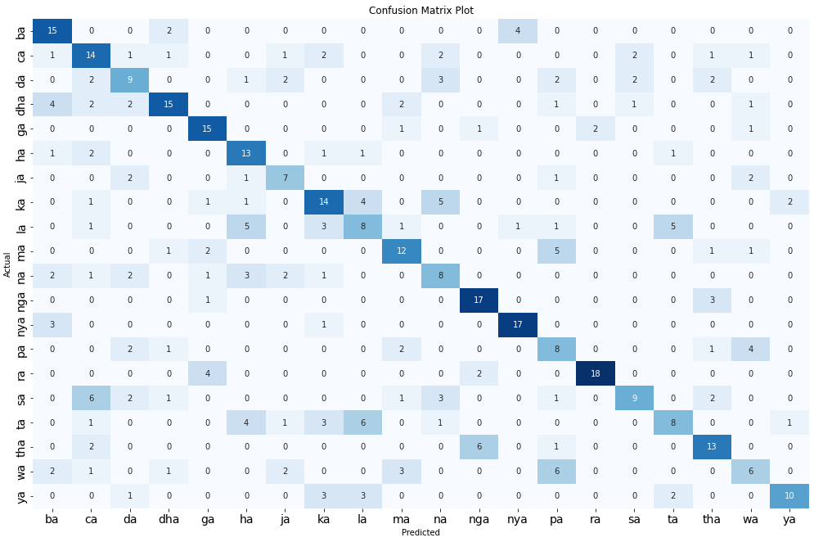

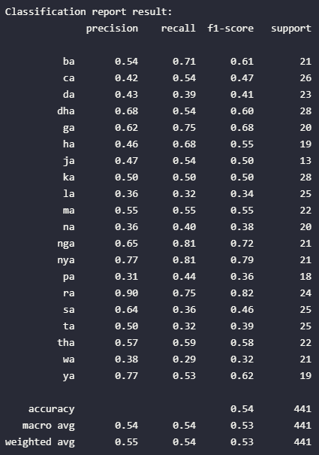

# Scenario 16

| **params** | **rank_test_score** | **mean_test_score** | **std_test_score** |
| --- | --- | --- | --- |
| **kernel** |  |  |  |  |
| 15_0.24383 | {'C': 15, 'gamma': 0.24383} | 1 | 0.858346 | 0.019011 |
| 10_0.24383 | {'C': 10, 'gamma': 0.24383} | 1 | 0.858346 | 0.019011 |
| 15_0.23885 | {'C': 15, 'gamma': 0.23885} | 3 | 0.858346 | 0.017884 |
| 10_0.23885 | {'C': 10, 'gamma': 0.23885} | 3 | 0.858346 | 0.017884 |
| 6_0.23885 | {'C': 6, 'gamma': 0.23885} | 5 | 0.857946 | 0.016320 |
| 6_0.24383 | {'C': 6, 'gamma': 0.24383} | 5 | 0.857946 | 0.017457 |
| 15_0.25877 | {'C': 15, 'gamma': 0.25877} | 7 | 0.857945 | 0.017279 |
| 10_0.25877 | {'C': 10, 'gamma': 0.25877} | 7 | 0.857945 | 0.017279 |
| 15_0.24881 | {'C': 15, 'gamma': 0.24881} | 9 | 0.857545 | 0.018110 |
| 10_0.24881 | {'C': 10, 'gamma': 0.24881} | 9 | 0.857545 | 0.018110 |
| 10_0.25379 | {'C': 10, 'gamma': 0.25379} | 11 | 0.857145 | 0.017805 |
| 6_0.25877 | {'C': 6, 'gamma': 0.25877} | 11 | 0.857145 | 0.016007 |
| 15_0.25379 | {'C': 15, 'gamma': 0.25379} | 11 | 0.857145 | 0.017805 |
| 6_0.24881 | {'C': 6, 'gamma': 0.24881} | 14 | 0.856745 | 0.016882 |
| 3_0.24383 | {'C': 3, 'gamma': 0.24383} | 14 | 0.856745 | 0.016105 |
| 3_0.23885 | {'C': 3, 'gamma': 0.23885} | 16 | 0.856745 | 0.015401 |
| 3_0.25877 | {'C': 3, 'gamma': 0.25877} | 17 | 0.855945 | 0.015412 |
| 3_0.24881 | {'C': 3, 'gamma': 0.24881} | 17 | 0.855945 | 0.015721 |
| 6_0.25379 | {'C': 6, 'gamma': 0.25379} | 17 | 0.855945 | 0.017086 |
| 3_0.25379 | {'C': 3, 'gamma': 0.25379} | 20 | 0.855545 | 0.015638 |
| 1_0.24383 | {'C': 1, 'gamma': 0.24383} | 21 | 0.843940 | 0.021487 |
| 1_0.24881 | {'C': 1, 'gamma': 0.24881} | 22 | 0.843140 | 0.020904 |
| 1_0.23885 | {'C': 1, 'gamma': 0.23885} | 22 | 0.843140 | 0.021692 |
| 1_0.25877 | {'C': 1, 'gamma': 0.25877} | 24 | 0.843139 | 0.020248 |
| 1_0.25379 | {'C': 1, 'gamma': 0.25379} | 24 | 0.843139 | 0.020248 |

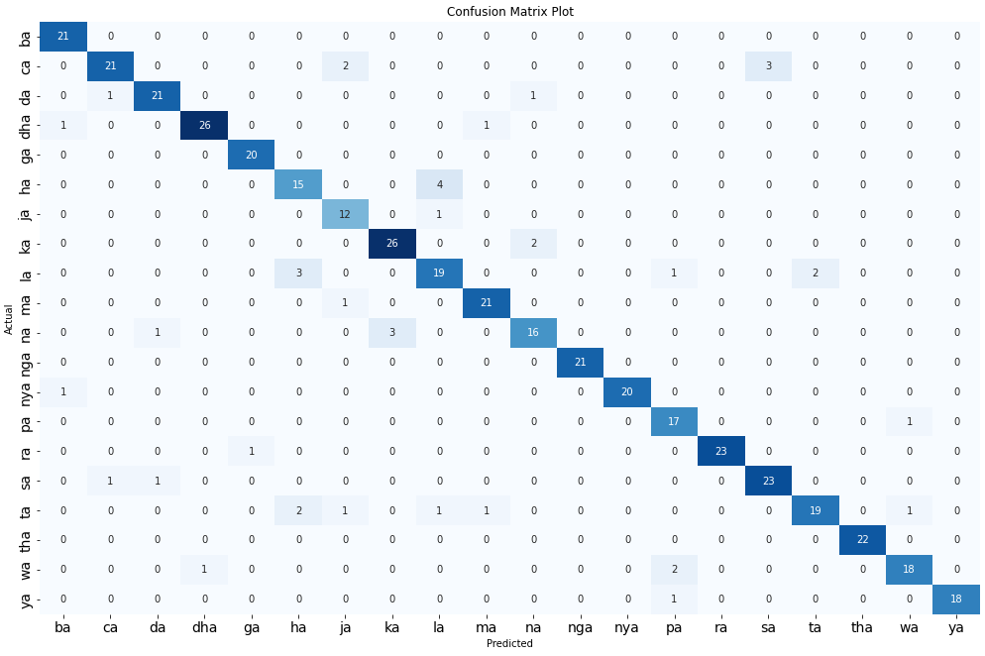

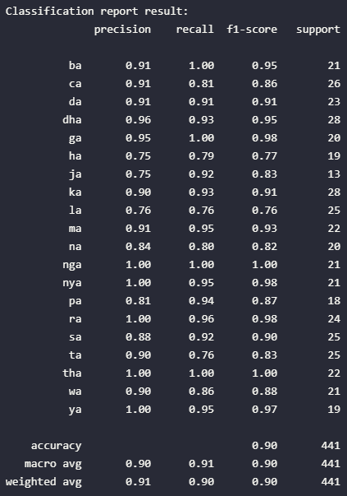

# Scenario 17

| **params** | **rank_test_score** | **mean_test_score** | **std_test_score** |
| --- | --- | --- | --- |
| **kernel** |  |  |  |  |
| 6_0.19929 | {'C': 6, 'gamma': 0.19929} | 1 | 0.879959 | 0.013028 |
| 15_0.19929 | {'C': 15, 'gamma': 0.19929} | 1 | 0.879959 | 0.013028 |
| 15_0.19131 | {'C': 15, 'gamma': 0.19131} | 1 | 0.879959 | 0.012399 |
| 10_0.19929 | {'C': 10, 'gamma': 0.19929} | 1 | 0.879959 | 0.013028 |
| 10_0.19131 | {'C': 10, 'gamma': 0.19131} | 1 | 0.879959 | 0.012399 |
| 6_0.19131 | {'C': 6, 'gamma': 0.19131} | 1 | 0.879959 | 0.012399 |
| 3_0.19131 | {'C': 3, 'gamma': 0.19131} | 7 | 0.879958 | 0.011190 |
| 15_0.1953 | {'C': 15, 'gamma': 0.1953} | 8 | 0.879559 | 0.013533 |
| 10_0.20727 | {'C': 10, 'gamma': 0.20727} | 8 | 0.879559 | 0.013533 |
| 10_0.1953 | {'C': 10, 'gamma': 0.1953} | 8 | 0.879559 | 0.013533 |
| 6_0.20727 | {'C': 6, 'gamma': 0.20727} | 8 | 0.879559 | 0.013533 |
| 15_0.20727 | {'C': 15, 'gamma': 0.20727} | 8 | 0.879559 | 0.013533 |
| 6_0.1953 | {'C': 6, 'gamma': 0.1953} | 8 | 0.879559 | 0.013533 |
| 15_0.20328 | {'C': 15, 'gamma': 0.20328} | 14 | 0.879159 | 0.013951 |
| 6_0.20328 | {'C': 6, 'gamma': 0.20328} | 14 | 0.879159 | 0.013951 |
| 10_0.20328 | {'C': 10, 'gamma': 0.20328} | 14 | 0.879159 | 0.013951 |
| 3_0.20727 | {'C': 3, 'gamma': 0.20727} | 17 | 0.879158 | 0.013608 |
| 3_0.19929 | {'C': 3, 'gamma': 0.19929} | 17 | 0.879158 | 0.013006 |
| 3_0.1953 | {'C': 3, 'gamma': 0.1953} | 19 | 0.879158 | 0.012121 |
| 3_0.20328 | {'C': 3, 'gamma': 0.20328} | 20 | 0.878758 | 0.014069 |
| 1_0.20727 | {'C': 1, 'gamma': 0.20727} | 21 | 0.868759 | 0.016204 |
| 1_0.20328 | {'C': 1, 'gamma': 0.20328} | 22 | 0.867959 | 0.016222 |
| 1_0.1953 | {'C': 1, 'gamma': 0.1953} | 23 | 0.867958 | 0.015776 |
| 1_0.19131 | {'C': 1, 'gamma': 0.19131} | 24 | 0.867558 | 0.015693 |
| 1_0.19929 | {'C': 1, 'gamma': 0.19929} | 25 | 0.867158 | 0.016055 |

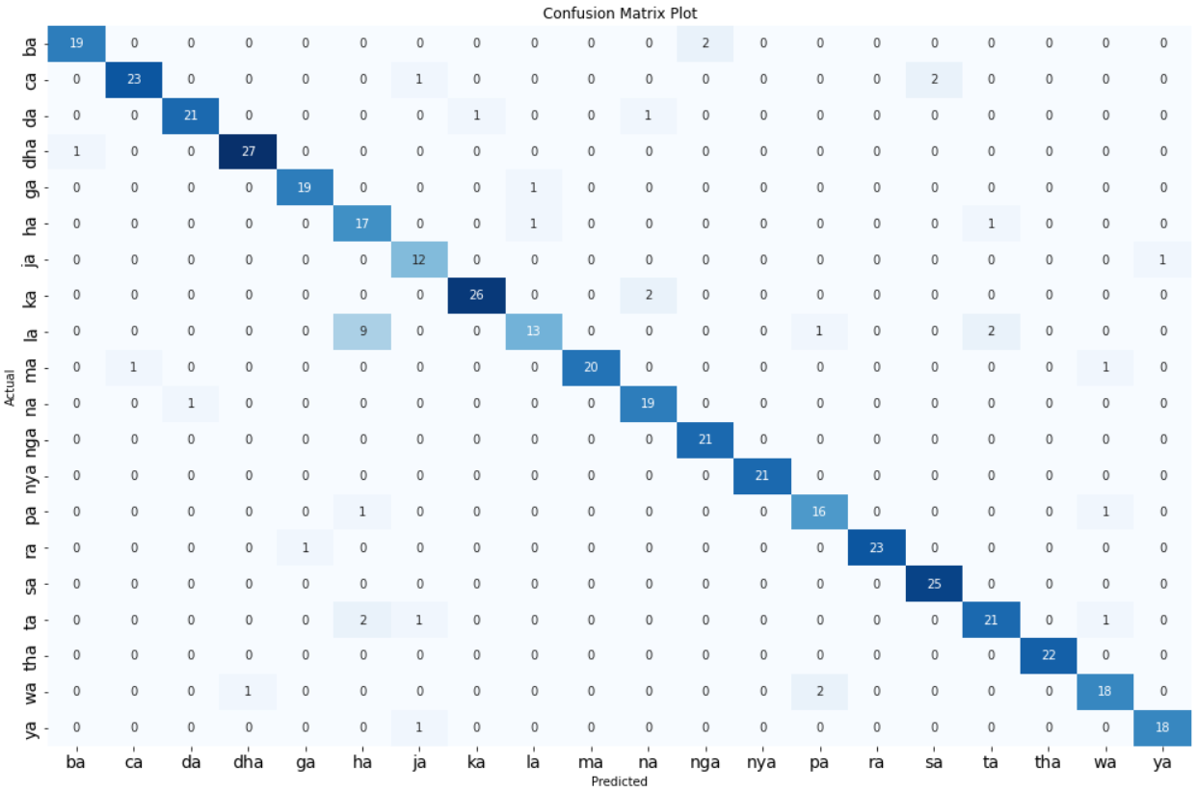

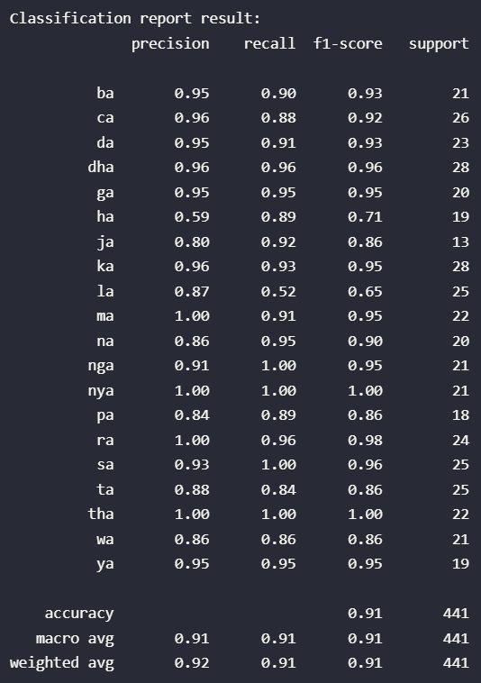

# Scenario 18

| **params** | **rank_test_score** | **mean_test_score** | **std_test_score** |
| --- | --- | --- | --- |
| **kernel** |  |  |  |  |
| 3_0.11659 | {'C': 3, 'gamma': 0.11659} | 1 | 0.891962 | 0.007634 |
| 15_0.11659 | {'C': 15, 'gamma': 0.11659} | 2 | 0.891562 | 0.010018 |
| 10_0.11659 | {'C': 10, 'gamma': 0.11659} | 2 | 0.891562 | 0.010018 |
| 3_0.12135 | {'C': 3, 'gamma': 0.12135} | 4 | 0.891562 | 0.007674 |
| 3_0.11421 | {'C': 3, 'gamma': 0.11421} | 4 | 0.891562 | 0.008080 |
| 3_0.11897 | {'C': 3, 'gamma': 0.11897} | 4 | 0.891562 | 0.007674 |
| 10_0.11421 | {'C': 10, 'gamma': 0.11421} | 7 | 0.891162 | 0.010800 |
| 15_0.11421 | {'C': 15, 'gamma': 0.11421} | 7 | 0.891162 | 0.010800 |
| 6_0.11659 | {'C': 6, 'gamma': 0.11659} | 7 | 0.891162 | 0.009872 |
| 10_0.12135 | {'C': 10, 'gamma': 0.12135} | 10 | 0.890762 | 0.010499 |
| 6_0.12135 | {'C': 6, 'gamma': 0.12135} | 10 | 0.890762 | 0.010499 |
| 15_0.12135 | {'C': 15, 'gamma': 0.12135} | 10 | 0.890762 | 0.010499 |
| 6_0.11897 | {'C': 6, 'gamma': 0.11897} | 10 | 0.890762 | 0.009789 |
| 15_0.11897 | {'C': 15, 'gamma': 0.11897} | 10 | 0.890762 | 0.010499 |
| 6_0.11421 | {'C': 6, 'gamma': 0.11421} | 10 | 0.890762 | 0.010575 |
| 10_0.11897 | {'C': 10, 'gamma': 0.11897} | 10 | 0.890762 | 0.010499 |
| 3_0.12373 | {'C': 3, 'gamma': 0.12373} | 17 | 0.890762 | 0.007997 |
| 10_0.12373 | {'C': 10, 'gamma': 0.12373} | 18 | 0.889962 | 0.010373 |
| 15_0.12373 | {'C': 15, 'gamma': 0.12373} | 18 | 0.889962 | 0.010373 |
| 6_0.12373 | {'C': 6, 'gamma': 0.12373} | 18 | 0.889962 | 0.010373 |
| 1_0.11659 | {'C': 1, 'gamma': 0.11659} | 21 | 0.885158 | 0.011037 |
| 1_0.12135 | {'C': 1, 'gamma': 0.12135} | 22 | 0.884758 | 0.011456 |
| 1_0.11421 | {'C': 1, 'gamma': 0.11421} | 22 | 0.884758 | 0.012134 |
| 1_0.11897 | {'C': 1, 'gamma': 0.11897} | 24 | 0.884758 | 0.010742 |
| 1_0.12373 | {'C': 1, 'gamma': 0.12373} | 25 | 0.884358 | 0.011157 |

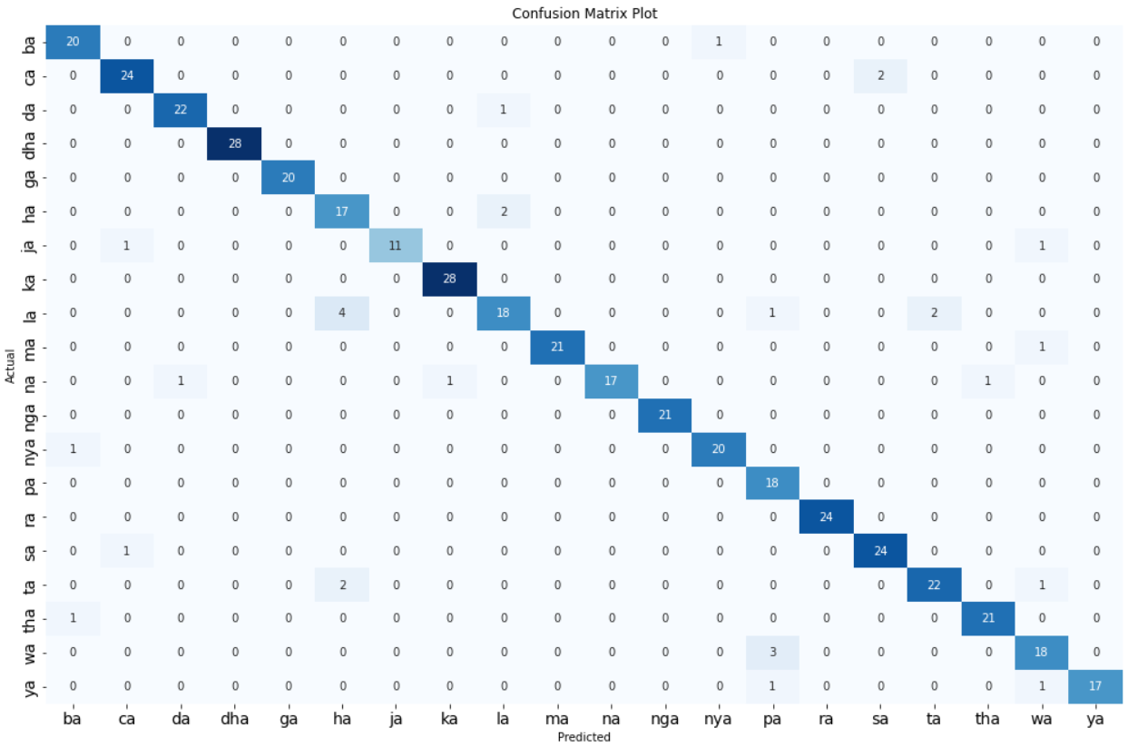

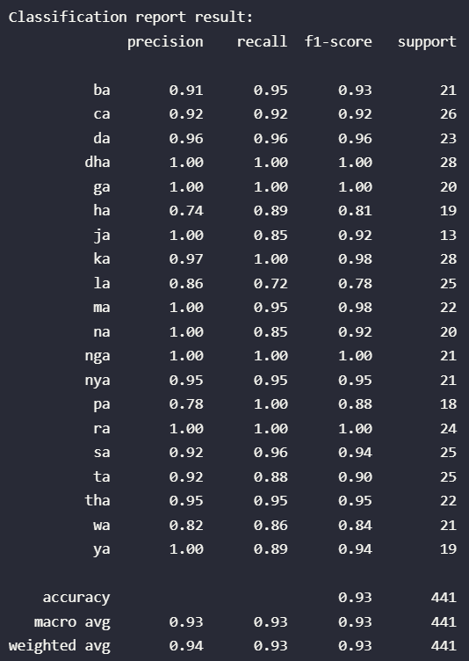

# Scenario 19

| **params** | **rank_test_score** | **mean_test_score** | **std_test_score** |
| --- | --- | --- | --- |
| **kernel** |  |  |  |  |
| 10_0.09026 | {'C': 10, 'gamma': 0.09026} | 1 | 0.909172 | 0.017152 |
| 15_0.09026 | {'C': 15, 'gamma': 0.09026} | 1 | 0.909172 | 0.017152 |
| 6_0.09026 | {'C': 6, 'gamma': 0.09026} | 1 | 0.909172 | 0.017152 |
| 15_0.09214 | {'C': 15, 'gamma': 0.09214} | 4 | 0.908372 | 0.018006 |
| 6_0.09214 | {'C': 6, 'gamma': 0.09214} | 4 | 0.908372 | 0.018006 |
| 3_0.09026 | {'C': 3, 'gamma': 0.09026} | 4 | 0.908372 | 0.016812 |
| 10_0.09214 | {'C': 10, 'gamma': 0.09214} | 4 | 0.908372 | 0.018006 |
| 3_0.09214 | {'C': 3, 'gamma': 0.09214} | 8 | 0.907572 | 0.017646 |
| 6_0.09402 | {'C': 6, 'gamma': 0.09402} | 9 | 0.907172 | 0.018146 |
| 10_0.09402 | {'C': 10, 'gamma': 0.09402} | 9 | 0.907172 | 0.018146 |
| 15_0.09402 | {'C': 15, 'gamma': 0.09402} | 9 | 0.907172 | 0.018146 |
| 3_0.09402 | {'C': 3, 'gamma': 0.09402} | 12 | 0.906772 | 0.018234 |
| 3_0.0959 | {'C': 3, 'gamma': 0.0959} | 12 | 0.906772 | 0.018234 |
| 15_0.0959 | {'C': 15, 'gamma': 0.0959} | 14 | 0.906771 | 0.017656 |
| 6_0.0959 | {'C': 6, 'gamma': 0.0959} | 14 | 0.906771 | 0.017656 |
| 10_0.0959 | {'C': 10, 'gamma': 0.0959} | 14 | 0.906771 | 0.017656 |
| 3_0.09778 | {'C': 3, 'gamma': 0.09778} | 17 | 0.905973 | 0.019188 |
| 10_0.09778 | {'C': 10, 'gamma': 0.09778} | 18 | 0.905972 | 0.018597 |
| 15_0.09778 | {'C': 15, 'gamma': 0.09778} | 18 | 0.905972 | 0.018597 |
| 6_0.09778 | {'C': 6, 'gamma': 0.09778} | 18 | 0.905972 | 0.018597 |
| 1_0.09402 | {'C': 1, 'gamma': 0.09402} | 21 | 0.896364 | 0.017744 |
| 1_0.09214 | {'C': 1, 'gamma': 0.09214} | 21 | 0.896364 | 0.016866 |
| 1_0.09026 | {'C': 1, 'gamma': 0.09026} | 23 | 0.895964 | 0.017315 |
| 1_0.09778 | {'C': 1, 'gamma': 0.09778} | 24 | 0.895164 | 0.017570 |
| 1_0.0959 | {'C': 1, 'gamma': 0.0959} | 25 | 0.895164 | 0.018501 |

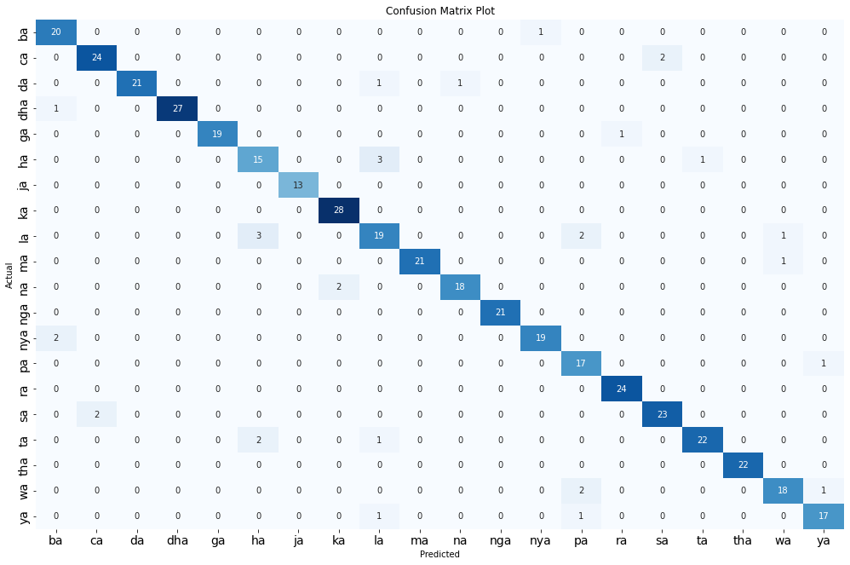

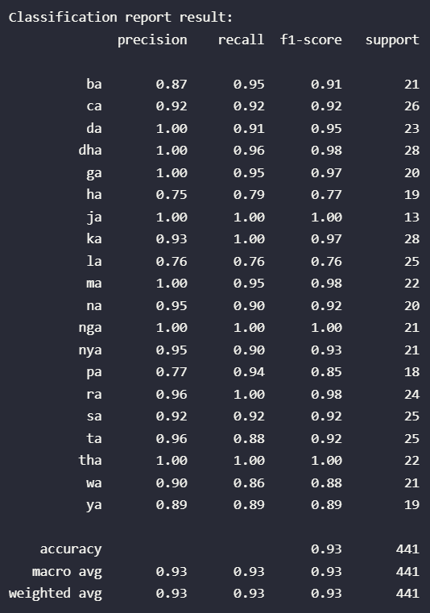

# Scenario 20

| **params** | **rank_test_score** | **mean_test_score** | **std_test_score** |
| --- | --- | --- | --- |
| **kernel** |  |  |  |  |
| 15_0.07609 | {'C': 15, 'gamma': 0.07609} | 1 | 0.904770 | 0.012054 |
| 6_0.07609 | {'C': 6, 'gamma': 0.07609} | 1 | 0.904770 | 0.012054 |
| 10_0.07609 | {'C': 10, 'gamma': 0.07609} | 1 | 0.904770 | 0.012054 |
| 10_0.07767 | {'C': 10, 'gamma': 0.07767} | 4 | 0.904770 | 0.011305 |
| 15_0.07767 | {'C': 15, 'gamma': 0.07767} | 4 | 0.904770 | 0.011305 |
| 6_0.07767 | {'C': 6, 'gamma': 0.07767} | 4 | 0.904770 | 0.011305 |
| 10_0.07925 | {'C': 10, 'gamma': 0.07925} | 7 | 0.903970 | 0.012079 |
| 6_0.07925 | {'C': 6, 'gamma': 0.07925} | 7 | 0.903970 | 0.012079 |
| 15_0.07925 | {'C': 15, 'gamma': 0.07925} | 7 | 0.903970 | 0.012079 |
| 3_0.07609 | {'C': 3, 'gamma': 0.07609} | 10 | 0.903970 | 0.011882 |
| 3_0.07767 | {'C': 3, 'gamma': 0.07767} | 11 | 0.903969 | 0.011193 |
| 3_0.07925 | {'C': 3, 'gamma': 0.07925} | 12 | 0.903170 | 0.011853 |
| 10_0.08083 | {'C': 10, 'gamma': 0.08083} | 13 | 0.901969 | 0.011813 |
| 15_0.08083 | {'C': 15, 'gamma': 0.08083} | 13 | 0.901969 | 0.011813 |
| 6_0.08083 | {'C': 6, 'gamma': 0.08083} | 13 | 0.901969 | 0.011813 |
| 3_0.08083 | {'C': 3, 'gamma': 0.08083} | 16 | 0.901568 | 0.011147 |
| 10_0.08241 | {'C': 10, 'gamma': 0.08241} | 17 | 0.900368 | 0.012041 |
| 15_0.08241 | {'C': 15, 'gamma': 0.08241} | 17 | 0.900368 | 0.012041 |
| 3_0.08241 | {'C': 3, 'gamma': 0.08241} | 17 | 0.900368 | 0.012041 |
| 6_0.08241 | {'C': 6, 'gamma': 0.08241} | 17 | 0.900368 | 0.012041 |
| 1_0.07609 | {'C': 1, 'gamma': 0.07609} | 21 | 0.893165 | 0.010180 |
| 1_0.07925 | {'C': 1, 'gamma': 0.07925} | 22 | 0.892362 | 0.008833 |
| 1_0.07767 | {'C': 1, 'gamma': 0.07767} | 23 | 0.891963 | 0.009145 |
| 1_0.08083 | {'C': 1, 'gamma': 0.08083} | 24 | 0.890762 | 0.009870 |
| 1_0.08241 | {'C': 1, 'gamma': 0.08241} | 25 | 0.889562 | 0.010555 |

